Academy Facilitator
Certification Policy

© State of Victoria (Victorian Academy of Teaching and Leadership) 2022
Academy Facilitator Program is provided under a Creative Commons Attribution 4.0 International licence. You are free to re-use the work under that licence, on the condition that you credit the State of Victoria (Victorian Academy of Teaching and Leadership), indicate if changes were made and comply with the other licence terms, see: Creative Commons Attribution 4.0 International
The licence does not apply to: any images, photographs, trademarks or branding, including the Victorian Government logo, Victorian Academy of Teaching and Leadership logo, Independent Schools Victoria logo, Catholic Education Commission of Victoria logo and the Department of Education logo; and content supplied by third parties. Queries may be directed to academy@education.vic.gov.au

Contents
Contents 3
Purpose 4
Context 4
Scope 4
Requirements 5
Certification 5
Renewal of certification 5
Compliance and consequences 6
Policy governance 7
Key principles 7
Definitions 7
Roles and responsibilities 8
Policy review 8

Purpose
The Academy Facilitator Certification Policy (the policy) establishes the Victorian Academy of Teaching and Leadership’s (Academy) standards for Victorian educators to become Academy Certified Facilitators.
The purpose of this policy is to ensure a rigorous process for certification as an Academy Certified Facilitator.
The certification process ensures a high-quality experience for Academy professional learning program participants and supports the Academy's position as a leader in providing evidence-informed and high-quality professional learning across Victoria.

Context
The Academy is committed to improving educational leadership and teaching practice across all three education sectors in Victoria through the delivery of high-quality professional learning programs, resources, pathways, and by raising the status of the profession.
The effectiveness of the Academy's professional learning is influenced by the capability of those who facilitate them. Developing facilitation expertise through professional learning supports consistent, high-quality delivery of some of the Academy's core programs.
The Academy adopts a ‘train-the-trainer’ approach to build facilitation capability among education leaders who are best positioned to influence teaching and leadership practice at scale. The approach supports context-responsive delivery of select Academy programs and supports the consistent, sustainable extension of Academy professional learning across the system.
Through the Academy Facilitator Program, the certification policy and the certification process, the Academy establishes clear expectations for facilitator capability and practice. This supports consistency and quality across Academy programs, builds state-wide expertise, and enables a scalable workforce of expert facilitators aligned with the Academy’s pedagogical approaches.

Scope
This policy applies to Academy Facilitator Program participants who:
- are employees of the Victorian Department of Education (including both Teaching Service and Victorian Public Service); or
- are employees of a Victorian independent school; or
- are employees of a school within the Victorian Catholic sector;
and who have completed each of the following:
- Academy Facilitator Program
- Academy content specialisation program
- Facilitation of at least one intake of Literacy Pedagogy and Practice, Mathematics Pedagogy and Practice and/or Inspire: Emerging Leaders
This policy specifically covers the Academy Facilitator Program developed by the Academy. It does not include facilitators of professional learning programs delivered by external providers (e.g. Leading Quality Conversations facilitator program), unless otherwise explicitly stated.

Requirements

Certification
The criteria for Academy Facilitator Certification include:
- Completion of the Academy Facilitator Program: Successful participation in the mandatory two-day facilitator program. The Academy Facilitator Program demonstrates best practice in facilitation to diverse adult audiences. It equips participants with the knowledge and expertise to strengthen their facilitation practice to meet and uphold the following Academy Standards of Facilitation:
- Cultivate a culturally safe and inclusive environment through responsive language and universal learning design
- Calibrate support and challenge to move participants through their zone of proximal development
- Engage in reflective practice by seeking, analysing, and acting on participant and peer feedback.
- Develop a deep understanding of the Academy Leadership Excellence Framework and content of the program being delivered
- Maintain facilitator presence throughout delivery ensuring engagement and interaction with participants.
- Completion of content specialisation: Successful participation in the content specialisation component for the Academy program(s) the facilitator intends to deliver.
- Successful delivery of one program demonstrating competency: Assessment of facilitation skills through observed practice, co-facilitation, or other practical assessments to ensure adherence to Academy standards. Information used to make this assessment can include:
  - Peer observation and feedback
  - Observation by senior Academy staff and/or
  - Participant feedback.
- Adhere to Departmental values and policies: see Legislative Context section below.

Renewal of certification
The Academy reviews facilitator status in a two-year cycle to ensure ongoing competence and alignment with education sector needs and best practice.
To maintain certification, an Academy Certified Facilitator will be expected to show evidence of:
- Professional learning: Engagement in learning and development activities to maintain and enhance facilitation skills. This includes mandatory attendance at an Academy-hosted annual symposium and recommended attendance at facilitator forums and/or workshops. Attendance will be documented to support facilitator recertification.
- Ongoing delivery of Academy programs: Academy certified facilitators must facilitate at least one intake of a relevant Academy program at least once every two years.
- Uphold Academy Standards of Facilitation: Assessment of facilitation skills through observed practice, co-facilitation, or other practical assessments to ensure adherence to Academy standards.
- Current employment: Be an employee of the Victorian Department of Education (either teaching service or Victorian Public Sector), of a Victorian independent school or of a school in the Victorian Catholic sector.
- Adhere to Departmental values and policies: see Legislative Context section below.
If an Academy Certified Facilitator takes extended leave (12 weeks or more) from their role, they can pause their certification status and restart it on their return. An Academy Certified Facilitator can pause their certification for a maximum period of one year within the two-year certification period without having to complete the certification process again. Requests to pause certification status can be addressed to the policy contact: Manager, Professional Learning Partnerships, Leadership Excellence Division, via email Academy.Support@education.vic.gov.au.
Those who have completed Literacy/Numeracy Master Trainers, Facilitator Training: Literacy/Numeracy Pedagogy and Practice, Inspire: Facilitator Training in 202425 and facilitated the respective program, are not required to complete the Academy Facilitator Program and content specialisation to be recognised as an Academy Certified Facilitator. They are required to meet the recertification criteria above to maintain their certification.
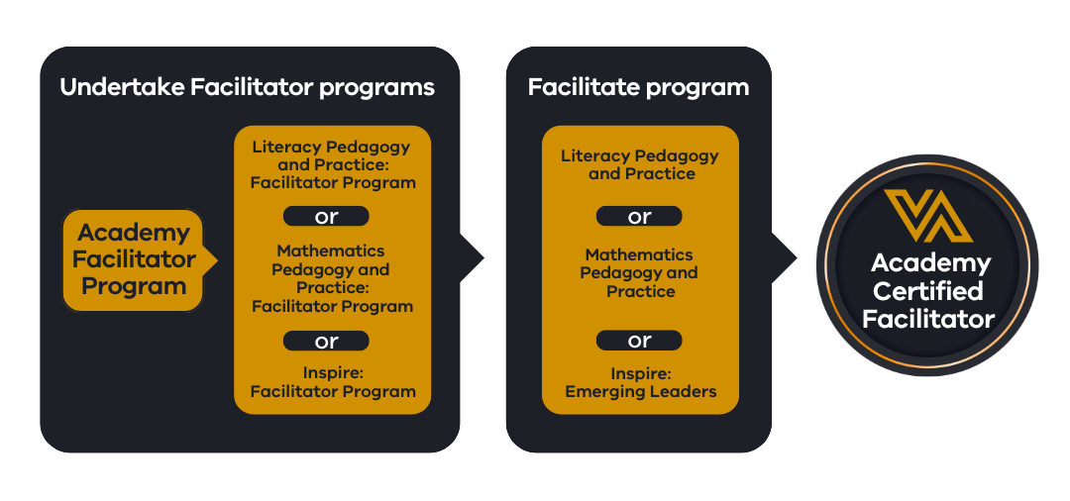
Figure 1 – Certification of Academy Certified Facilitators

Compliance and consequences
Adherence to this policy is mandatory for all individuals seeking or maintaining Academy Certified Facilitator status. Non-compliance, including failure to meet certification or renewal requirements, or uphold expected standards of facilitation, may result in:
- a requirement for additional training or mentoring, which will be provided by the Academy.
- the temporary suspension of Academy Certified Facilitator status until noncompliance is resolved
- revocation of Academy Certified Facilitator status.

Policy governance
The policy co-owners are the Director, Teaching Excellence Division (TED) and Director, Leadership Excellence Division (LED). A dedicated program stream team within LED manages and monitors the certification process, overseen by the Director, LED. This reports through the Leadership Excellence Division to the Academy Chief Executive Officer.

Key principles
The Academy enacts this policy using the following principles:
- Certification decisions are made consistently, using transparent requirements applied equitably across participants and programs.
- The Academy retains authority for certification decisions and is accountable for the standards under which certification is granted or revoked.
- The Academy uses participant and other feedback to ensure continued relevance of the requirements.

Definitions
Term | Definition
Academy | Victorian Academy of Teaching and Leadership
Academy Facilitator Program (AFP) | A two-day professional learning program developed and delivered by the Academy.
Certification | An internal process by which the Academy formally recognises an individual's demonstrated competence and proficiency in facilitating its programs according to defined requirements.
Academy Certified Facilitator | An individual who has successfully completed the Academy Facilitator Certification process and met all other relevant requirements in delivering professional learning to a high standard.
Content specialisation | Content specialisations are the specific programs in which the participants develop their knowledge and skills to deliver professional learning programs, build collective capacity and advance teaching practice to improve student learning outcomes. Specialisations are in literacy, mathematics and leadership.
LED | Leadership Excellence Division
TED | Teaching Excellence Division

Roles and responsibilities
Role | Responsibility
Academy CEO | Endorsement of the Academy Facilitator Certification Policy.  Oversee the strategic direction of the Academy Facilitator Program.  Approve major policy revisions.
Academy Directors, LED and TED | Oversee the development, management, and continuous improvement of the Academy Facilitator Program and the certification process, and associated content specialisation programs.  Ensure accurate records of certified facilitators and their ongoing development are maintained.  Oversee support of the Academy Certified Facilitator cohort.
Academy Certified Facilitators | Adhere to Academy policies and procedures, including this Academy Facilitator Certification Policy.  Uphold Academy values and standards and promote the benefits of engagement with the Academy programs and resources.  Participate in feedback and quality assurance processes.

Legislative context
- Education and Training Reform Act 2006 (Vic)
- Privacy and Data Protection Act 2014 (Vic) and/or the Privacy Act 1988 (Cth)

Policy review
A policy review is conducted annually, led by the policy key contact and presented to the CEO for re-endorsement to ensure its continued relevance, effectiveness, and alignment with organisational goals and best practices in professional learning.
Endorsed by | Director, Leadership Excellence Division, Academy  Director, Teaching Excellence Division, Academy
Authorised by | Chief Executive Officer, Academy
Date effective | 27 January 2026
Next review date | 26 January 2027
Policy key contact | Manager, Professional Learning Partnerships, Leadership Excellence Division, Academy by email to Academy.Support@education.vic.gov.au

