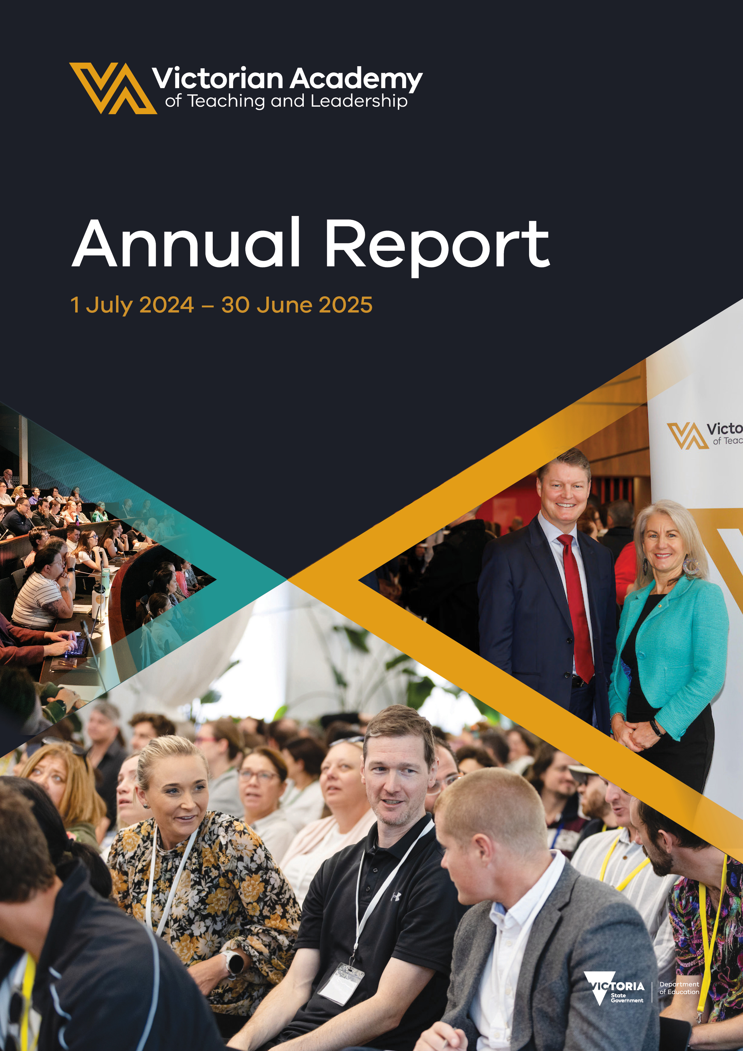

© State of Victoria (Victorian Academy
of Teaching and Leadership) 2025
The Victorian Academy of Teaching and Leadership’s 2025 Annual Report is provided under a Creative Commons Attribution 4.0 International licence. You are free to re-use the work under that licence, on the condition that you credit the State of Victoria (Victorian Academy of Teaching and Leadership), indicate if changes were made and comply with the other licence terms. See: Creative Commons Attribution 4.0 International.
The licence does not apply to any images, photographs, trademarks or branding, including the Victorian Government logo, Victorian Academy of Teaching and Leadership logo, Independent Schools Victoria logo, Victorian Catholic Education Authority logo and the Department of Education logo; and content supplied by third parties. Queries may be directed to academy@education.vic.gov.au.

Contents
Report of Operations 7
Year in Review 7
Chair and CEO report 7
Highlights 9
Teaching Excellence Program 12
Leadership excellence programs 16
Academy regional centres 20
Strategic plan 23
Academy measures of success and indicators and targets (outputs) 24
Financial summary 25
Organisational structure 26
Organisational structure and corporate governance arrangements 26
Senior leadership 27
Board 31
Audit and Risk Committee 35
Organisational structure 36
Occupational health and safety 37
Employment and conduct principles 38
Workforce data 39
Comparative workforce data 40
Workforce inclusion policy 42
Executive data 43
Other disclosures and attestations 44
Financial Report 52
Financial Report 52
How this financial report is structured 52
Financial statements 52
Accountable Officer’s declaration 54
Comprehensive operating statement for the financial year ended 30 June 2025 57
Balance sheet as at 30 June 2025 58
Cash flow statement for the financial year ended 30 June 2025 59
Statement of changes in equity for the financial year ended 30 June 2025 60
Notes to the financial statements for the financial year ended 30 June 2025 61
Appendices 85

Responsible Body Declaration



Responsible Body Declaration
In accordance with the Financial Management Act 1994, I am pleased to present the Victorian Academy of Teaching and Leadership Annual Report for the year period
1 July 2024 ending 30 June 2025.



Dr Toni Meath

Chair

Victorian Academy of Teaching and Leadership
22 September 2025

Acknowledgement
The Board of the Victorian Academy of Teaching and Leadership acknowledges the Traditional Owners of the lands and waters on which we live and work, and we pay our respects to Elders past and present. We recognise the unique status of Aboriginal and Torres Strait Islander people as Australia’s First Nations Peoples and seek to enrich our whole society with an improved knowledge, understanding and appreciation of Australia’s First Nations Peoples’ history and culture.
The Board commits to the vision of Marrung Aboriginal Education Plan 2016–2026 that:
Victoria will be a state where the rich and thriving cultures, knowledge and experience of our First Nations peoples are celebrated by all Victorians; where our universal systems are inclusive, responsive and respectful of Aboriginal people at every stage of their learning and development journey; and where every Aboriginal person achieves their potential, succeeds in life and feels strong in their cultural identity.
The Academy’s mission is to enhance and improve student outcomes across rural, regional and metropolitan schools through specialised professional learning. Through the key enabler ‘a culture of professional leadership’ identified in Marrung, the Academy is committed to ensuring First Nations teachers and leaders in Victorian schools have equal access to our programs.
We commit to the Treaty principles of self-determination and empowerment, fairness and equality, partnership and good faith, mutual benefit and sustainability, and transparency and accountability.

The Academy’s guiding principles

Objectives and functions
The Victorian Academy of Teaching and Leadership (the Academy) is established through Section 2.6A.4 of Victoria’s Education and Training Reform Act 2006.
The Academy is committed to delivering the following objectives outlined in the legislation:
- to improve the outcomes for school students through the provision of specialised teaching and leadership excellence programs for exceptional teachers and school leaders
- to increase equity of access to professional learning to lift the quality of teaching across Victoria
- to provide a dedicated pathway for established exceptional teachers to contribute to school and system improvement
- to improve the quality of school leadership
- to raise public awareness of the capability and status of school leaders and teachers in the science and practice of teaching.
The functions of the Academy are:
- to provide advice to the Minister for Education and the Department of Education (DE) in relation to:
  - school leadership
  - teaching and professional practice
  - professional learning
- to design and provide accredited and non-accredited professional learning programs for school leaders and teachers, including specialised teaching and leadership excellence programs
- to develop and publish guidance materials and resources for use by providers of professional learning programs to evaluate the effectiveness and impact of the Academy’s professional learning programs, including in relation to teaching practice and outcomes for students
- to work collaboratively with schools, community organisations, universities, post-compulsory education and training providers, professional associations and providers of professional learning programs to:
  - identify the needs of the teaching profession
  - support and improve the delivery of the Academy’s professional learning programs, including specialised teaching and leadership excellence programs
- to improve public confidence in the teaching profession and schools in Victoria through the promotion of the use of evidence-informed practice among school leaders and teachers
- any other function conferred on or delegated to the Academy by or under the ETR Act of any other Act

Vision
A centre for excellence in school teaching and leadership.

Mission
Enhance and improve student outcomes across rural, regional and metropolitan schools through specialised professional learning.

Values
The Academy upholds the Victorian Government public sector values:
- Responsiveness
- Integrity
- Impartiality
- Accountability
- Respect
- Leadership
- Human Rights

Report of Operations

Year in Review

Chair and CEO report
In the 2024–25 reporting period, the Victorian Academy of Teaching and Leadership (the Academy) continued to expand its impact on government, Catholic and independent school sectors in Victoria. The Academy offers evidence-informed professional learning, events, resources and initiatives aimed at taking Victoria’s highly skilled teachers and leaders from great to exceptional. We also provide pathways for teachers and leaders to contribute to school and system improvement and undertake activities that raise public awareness and recognition of the profession’s expertise and impact.
Key achievements in the 2024–2025 reporting period include exceeding all participation and satisfaction output performance targets in our programs for the calendar year, expanding the Alumni program, the highest number of Teaching Excellence Program (TEP) participants in 2025 since establishment, opening the final regional centre in Bendigo with relocation to the permanent site in late 2024, and the appointment of 4 new Board members, who bring a diversity of skills and experience in educational leadership to our cross-sectoral Board.
The Academy also received further funding of $25.3m in the May 2025 budget to extend operations to the end of June 2026.
Hundreds of Victorian teachers from across all school sectors commenced the TEP, with 433 participants in 2024 and 499 in 2025. This program is the cornerstone of our commitment to empowering teachers and elevating the teaching profession across Victoria. By the end of 2025, there will be over 1,500 TEP graduates. To date, 99% of TEP graduates have indicated that the program had a ‘significant’ or ‘highly significant’ impact on their teaching practice.
In 2024–25, almost 50 Teaching Impact Fellowships were awarded, with teachers across the 3 sectors undertaking a range of transformational projects that have had impact within and beyond their classrooms and schools.
The Academy offers more than 40 high-quality professional learning programs for participants at all levels of school leadership, including classroom and middle leaders, those on the pathway to principalship, assistant principals and new and established principals. In 2024–25, our leadership excellence programs reached over 17,262 Victorian government school principals, teachers, leaders and other school staff at our metropolitan and regional sites.
We expanded our Alumni program in 2025. This means thousands of leadership excellence program graduates have now joined our TEP graduates in this network. The expanded Academy Alumni offers members opportunities to engage in professional learning and events to enhance their skills and individual and collective impact. The program commenced in March 2025 with an International Women’s Day panel featuring influential women in education.
In 2024–25, 236 Statements of Readiness were issued to graduates of the Victorian Aspiring Principal Assessment. This program ensures that Victoria’s next generation of principals is ready for the strategic, operational and people leadership aspects of the role, contributing to the Academy’s objective of improving school leadership.
The Academy is proud to host the Government Schools Principals Conference, making a significant contribution to school leadership. The conference brings school leaders together to connect, share insights and explore new ideas that drive school and classroom excellence. This annual event was delivered twice within the reporting period. It was attended by over 2,600 principals and leadership team members in July 2024, growing to 3,000 participants in June 2025.
All 7 Academy regional centres continue to have impact through delivering high-quality professional learning for teachers in regional and rural areas. These centres held 1,346 professional learning events in the reporting period, and 23,725 educational professionals used them for education-related activity.
We have provided government schools with strong support and guidance for implementing the Revised Victorian Teaching and Learning Model (VTLM 2.0) through professional learning. Relevant existing Academy programs have been redesigned to align with VTLM 2.0, and several new programs and events have been developed and launched.
We have published several resources to support leaders, teachers, parents and carers through the VTLM 2.0 rollout. For teachers, these include ‘Teaching reading and phonics’, a resources page supporting the teaching of reading in Victorian schools. This page contains FAQs, links to further resources and the ‘Evidence-informed Teaching of Reading’ webinar, which outlines the VTLM 2.0 and explores the evidence underpinning the teaching of reading. For parents and carers, Academy-produced resources include ‘Understanding Maths Anxiety’ to support positive engagement with mathematics at home, ‘Helping every child succeed: VTLM 2.0’ to improve understanding of new teaching and learning practices, and ‘Understanding phonics’ to support reading at home.
We thank the Academy Board for its leadership and commitment to the Academy’s objectives. Membership of the Academy Board changed significantly over the reporting period, and former and current members made valuable contributions to the Academy’s success in 2024–25.
The Academy is supported by an exceptional executive leadership team. We thank members of the executive team for their passion and commitment to leading the Academy to exceed its targets, establish and maintain an outstanding culture, and achieve its legislated objectives.
Similarly, each member of the Academy team, whether front of house or behind the scenes, plays a key role in ensuring the Academy’s success. We are grateful to them all for their high-quality contributions.
We are pleased to present this report of the 12 months of operation of the Academy from 1 July 2024 to 30 June 2025.



Dr Toni Meath

Chair


Dr Marcia Devlin AM

Chief Executive Officer


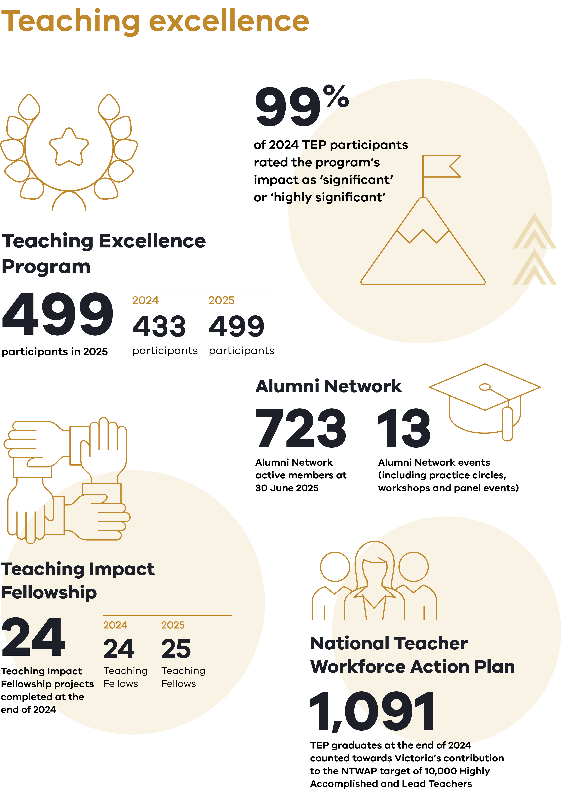

Highlights
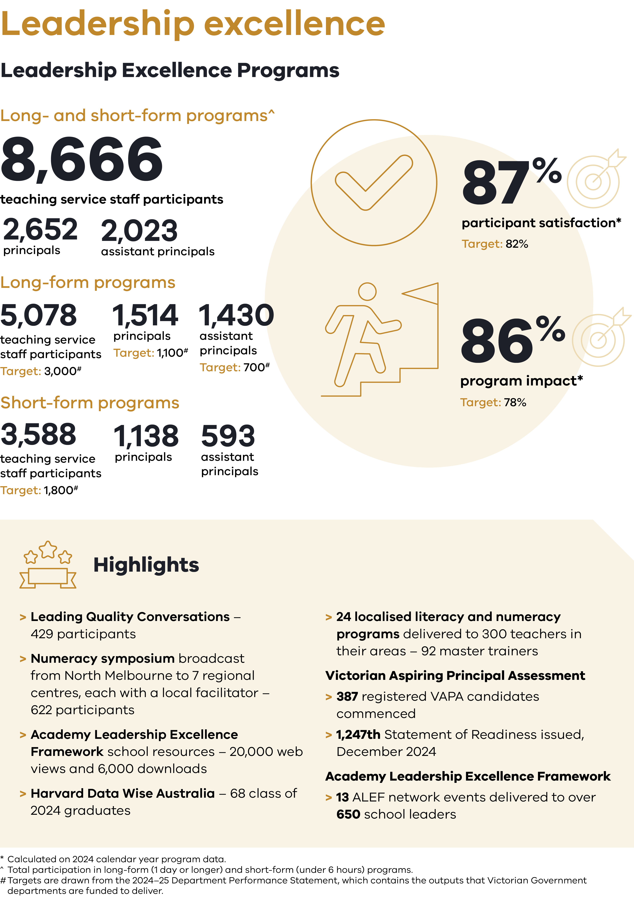
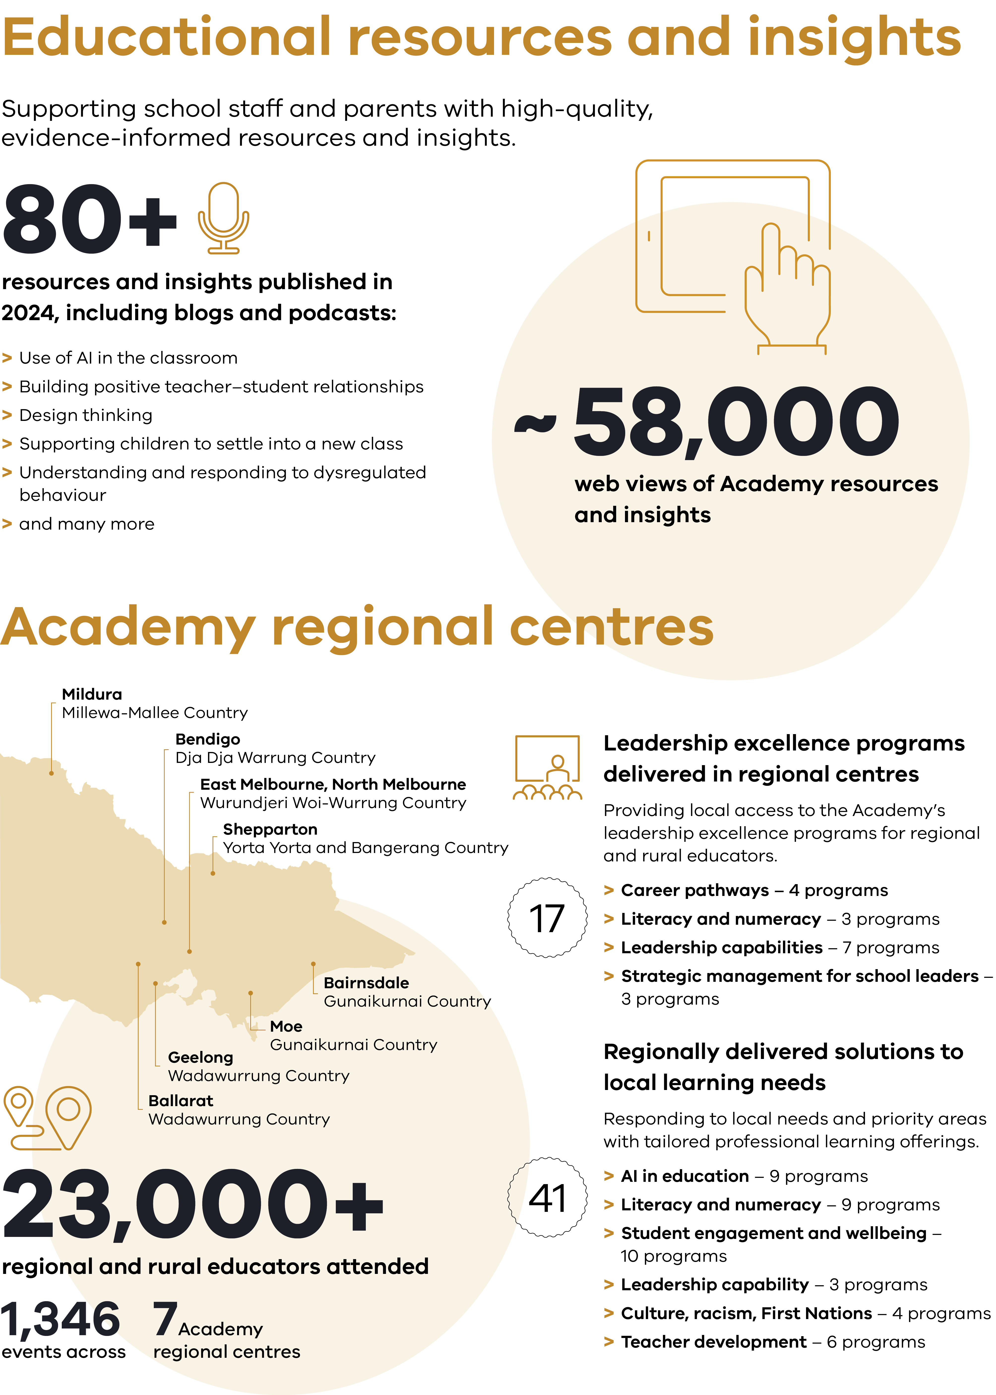

Teaching Excellence Program
The Teaching Excellence Program (TEP) is a year-long professional
learning program grounded in 8 key discipline areas.

The program draws on practitioner inquiry, teacher agency, reflective practice and contemporary evidence-informed research. Open to the Victorian government, Catholic and independent sectors,
the TEP is Australia’s first advanced professional learning program for highly skilled teachers.
In 2024 and in 2025, the TEP included 10 days of in-person professional learning. This included 2 conferences, 4 discipline days and 4 Teaching Excellence Learning Community (TELC) days. Schools receive casual relief teacher funding for these days, with an additional 4 days available to teachers should extra time be required to complete graduation tasks. The 2024 and 2025 TEP design was informed by evaluations of the 2022 and 2023 program, as well as feedback from participating teachers, Principals in Residence and Expert Teachers in Residence. The TEP design model is shown in Figure 1.
The TEP begins with a conference day. In 2024 and 2025 participants were welcomed by the Deputy Premier of Victoria and Minister for Education, the Hon. Ben Carroll MP. The conference day includes keynote sessions and discipline-based sessions
which explore themes around teaching and learning excellence.
The TEP discipline days are a unique opportunity to explore problems of practice related to teaching and learning in the disciplines. Discipline days provide access to contemporary research to enhance teaching practice that is evidence-informed and, where relevant, aligned to DE policy and initiatives,
including the Victorian Teaching and Learning Model 2.0 (VTLM 2.0).
The TELC days occur each term and are held across Victoria in East Melbourne and the Academy’s 7 regional centres. The TELCs operate as cross-disciplinary professional learning communities that focus on professional growth. Through practitioner inquiry, dispositions and collaboration, teachers further develop their expertise and commitment to excellence in their practice.
The TEP concludes with a conference where participants celebrate graduating from the TEP, helping to solidify networks created throughout the year. Participants reflect on the impact of the TEP on their teaching practice while looking towards the future and the actions and impacts they can continue to have on their students and schools, based on their learning.
Since its launch in 2022, there have been 1,091 graduates from the TEP, with a further 499 teachers undertaking TEP in 2025. TEP graduates count towards Victoria’s contribution to the National Teacher Workforce Action Plan target of 10,000 Highly Accomplished and Lead Teachers.
Figure 1: Teaching Excellence Program design model
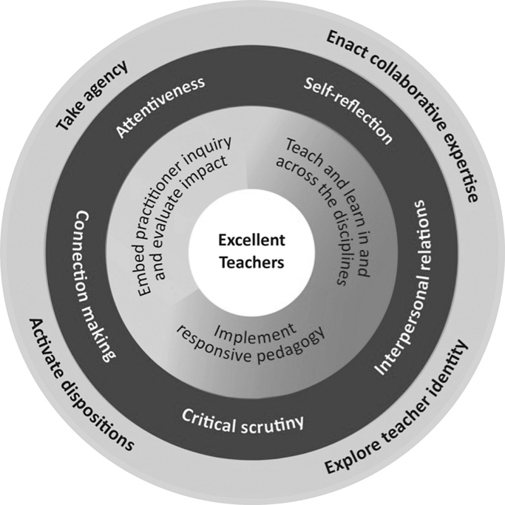

Teaching in the disciplines
The subject disciplines within the TEP are:
- The Arts
- English
- Health and Physical Education
- The Humanities
- Languages
- Mathematics
- Science
- Technologies
Table 1: TEP participation 2024–25
Total TEP participants | 2024 | 2025
Number of participants | 433 | 499
TEP participants by school type | 2024 | 2025
Secondary | 139 (32%) | 154 (31%)
Primary | 169 (39%) | 251 (50%)
Primary/secondary | 112 (26%) | 84 (17%)
Specialist | 11 (~2%) | 8 (~1%)
Other | 2 (~1%) | 2 (~1%)
TEP participants by sector type | 2024 | 2025
Government | 271 (63%) | 371 (74%)
Independent | 97 (22%) | 66 (13%)
Catholic | 66 (15%) | 62 (13%)
TEP participants by location | 2024 | 2025
Metropolitan | 283 (65%) | 348 (70%)
Regional | 75 (~17%) | 77 (15%)
Rural | 75 (~17%) | 74 (15%)
Note: The performance target for TEP in both 2024 and 2025 was 400.

Teaching Impact Fellowships
The Teaching Impact Fellowship (known as the Teaching Innovation Fellowship from 2023–24)
(TIF) program continued in 2024–25 with fellowships offered to select TEP graduates through a competitive application process. Successful applicants receive up to $5,000 to design and implement improvement projects that aim to transform teacher practice and student learning and/or wellbeing in their classrooms or schools.
The Academy supports and guides TIF fellows for the duration of their project through preparatory and ongoing professional learning.
The 2024 teacher fellows concluded their fellowship by presenting their innovation projects at the Teaching Innovation Fellowship Insights Summit in May 2025. The presentations centred on the projects’ impact and value on schools and networks. Teacher fellows demonstrated that through their projects they had:
- improved student learning and wellbeing outcomes
- increased teacher confidence and capability
- improved their ability to lead collaborative change
- created the conditions for sustainable impact following the conclusion of their fellowship.
Figure 2: Teaching Impact Fellowship Framework
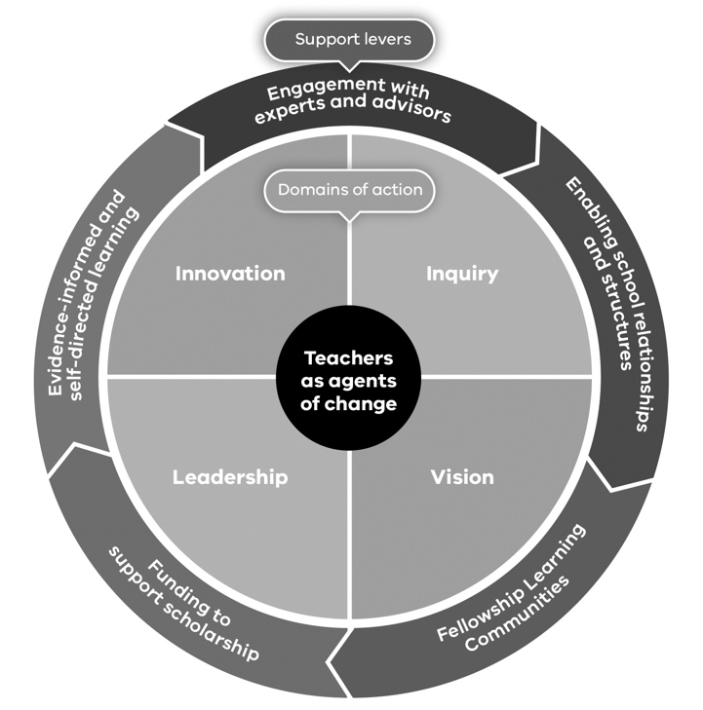

Academy Alumni program
(formerly the TEP Alumni Network)
Until the beginning of 2025, TEP graduates have been invited to join the TEP Alumni Network. This network offered members opportunities to engage in professional learning and events to further enhance their skills. Over 70% of TEP graduates since 2022 have joined the TEP Alumni Network and participated in various offerings.
At the start of 2025, the Academy commenced an expansion of the TEP Alumni Network to also include graduates of leadership excellence programs. The expanded Academy Alumni program commenced with a range of events including:
- an International Women’s Day panel featuring influential women in education
- a webinar exploring the future of generative artificial intelligence in the classroom
- a workshop on imperfect leadership facilitated by Steve Munby.

Expert Teachers in Residence
Expert Teachers in Residence (ETRs) are exceptional teachers who join the Academy for 12 months over a calendar year, seconded from their substantive school roles. They support the TEP by collaboratively planning and facilitating discipline days and TELC days to ensure the professional learning is high quality and meets the needs of participants. ETRs also support the TIF and Academy Alumni, and they contribute to other Academy and DE programs, resources and initiatives. DE draws on ETRs for advice on a range of projects related to teaching and learning, pedagogy, assessment and policy development.
Sixteen ETRs supported the TEP in 2024, each specialising in one of the disciplines and many supporting a second discipline. There were 4 ETRs for each of English A (primary) and Mathematics, 2 for English B (secondary), and one each for the Arts, Health and Physical Education, the Humanities, Languages, Science and Technologies.

Principals in Residence, Teaching Excellence Division
Principals in Residence (PiRs) join the Academy for 12–24 months from their substantive position as school principal. In 2024–25, there were 3 PiRs in the Teaching Excellence Division. The PiRs support the planning, provision, evaluation and improvement of the TEP, the TIF and the Academy Alumni program (formerly the TEP Alumni Network) and are part of the Teaching Excellence Division leadership team. They provide guidance and mentorship for the ETRs, including in team and culture building and with opportunities for professional growth and development. PiRs also contribute to Academy and DE initiatives including responding to the priorities of the Minister for Education, preparing resources and leading professional learning offerings.

Evaluation
Evaluation of the TEP, TIF and Academy Alumni program (formerly the TEP Alumni Network) involves several strategies to monitor impact. It is supported by the Academy’s Evaluation and Evidence Centre (EEC) as well as external independent evaluators.
The Academy commissioned an independent evaluator, Deloitte Access Economics, to evaluate the impact of the TEP, TIF and TEP Alumni Network in 2024. The aim of these evaluations was to determine what is working well, where improvements can be made and how these programs are contributing to the Academy’s objectives.
The 2024 TEP evaluation found that the TEP delivered overwhelmingly positive outcomes for participants, who reported a positive material impact on their knowledge, capability, disposition and practice. This has resulted in improvements in student learning outcomes. One participant stated:
“TEP has ignited a fire to build better classrooms and education based on professional reading. I have stretched my thinking, improved my practice, and I look forward to continuing to impact on my school community, not just on my classes.”
The evaluation also found that the TEP has inspired and rejuvenated teacher participants across the state, leading to increased teacher retention. One participant reported that the 2024 TEP:
“… allowed me to reflect on the reasons I am a teacher and the impact I can have on students. It had renewed a spark and joy for teaching that I felt I was beginning to lose from fatigue.”

The 2024 TEP evaluation found significant evidence of improved teacher capability. Teachers’ perceptions of their capability, disposition and skills in 5 areas increased after participating in the program – for example:
- practitioner inquiry (average 13-point increase compared to before their participation in TEP)
- dispositions (average 9-point increase)
- responsive pedagogies (average 15-point increase).
Qualitative evidence also demonstrated increased knowledge among TEP participants and confidence in applying their skills. The evaluation found positive impacts on:
- building professional practice – 97% of TEP participants in 2024 either ‘agreed’ or ‘strongly agreed’ that they were confident they could see evidence of the TEP’s impact on their teaching practice
- achieving student learning outcomes – in a 2024 post-TEP survey:
  - 99% of respondents indicated that the TEP had a ‘significant’ or ‘highly significant’ impact on their students’ learning outcomes
  - 98% of respondents ‘agreed’ or ‘strongly agreed’ that the TEP positively impacted student achievement by improving learning outcomes, student engagement and students’ connection to learning, peers and the broader school community
- retaining teachers, with some TEP teachers attributing their involvement in the program to positively changing their intention to remain in the profession
- fostering effective teacher networks, with some participants indicating they are seeking out professional connections beyond their own schools to support pedagogical improvement
- raising the status of the profession.
One participant from 2024 stated that the TEP ‘reminded me of the significance of our profession and the important role we play.’

Evidence of positive impact
The evaluations outlined above generated evidence of positive impact. Below are examples
of qualitative feedback from TEP evaluations grouped under 2 of the Academy’s objectives.
Academy objective: Improve outcomes for school students through the provision of specialised teaching and leadership excellence programs for exceptional teachers and school leaders
“I am a more competent, capable teacher now, which in turn positively impacts my relationships with my students and their outcomes.”
TEP participant, 2024

“My students’ voice grows louder, and this enables my cohort to ask more questions, direct the learning and improve outcomes.”
TEP participant, 2024
Academy objective: Provide a dedicated pathway for established exceptional teachers to contribute to school and system improvement
“[The TEP has] given me the confidence I needed in order to believe in myself and my knowledge to take the next steps in my teaching career, resulting in leading the grade 3/4 team of 7 colleagues.”
TEP participant, 2024

“I am now the Learning Specialist in my school. I would not have even considered the possibility if I hadn’t done TEP. This year has been the most transformative of my career and has led me down the path of curriculum development and implementation, an area I aspired to but didn’t think I would ever really get to. I am excited by teaching and learning again.”
TEP participant, 2024

Leadership excellence programs
The Academy offers a range of leadership excellence programs, which are available to the Victorian government, Catholic and independent sectors. These high-quality, evidence-informed programs contribute to a sustainable pipeline of highly capable and leadership-ready professionals across the state. They build the leadership capabilities of leaders at all career stages, ensuring excellence in school leadership and leading to equity and excellence in student learning and wellbeing.
Figure 3: Leadership excellence program overview
Leadership Excellence Programs | Emerging Leaders | Middle Leaders | Assistant Principals | Principals | System Leaders
Career Stage Programs
Inspire | 
Impact
Create
Connect
Unlocking Potential
Victorian Aspiring Principal Assessment (VAPA)
Evolve: New Principals
Executive Class Principals
WISE: System Leaders
Specialist Programs
Thought Leadership Series
Harvard Certificate in Instructional Leadership
Harvard Datawise
Strategic Management for School Leaders Suite
Innovating for Student Engagement
Data-Driven School Improvement
Leading School Improvement
Leading Quality Conversations
Leading with Emotional Intelligence
Mentoring and Leadership Coaching
Communities of Practice – Team Coaching for CoP Leaders
Women in Leadership
Dare to Lead
Clarity Learning Suite
Harvard Certificate in School Management and Leadership
Inspire Facilitator Training
Harvard Principals’ Centre
Leading Teaching, Learning & Wellbeing: Creating a Collaborative Culture
Leading Teaching, Learning & Wellbeing: Emerging Technologies in Education
Leading Teaching, Learning & Wellbeing: Future Focused Leadership
Leading Teaching, Learning & Wellbeing: Collaborative Complex Problem
Solving for School Leaders
Communities of Practice – Network Leaders’ Data Capability
Literacy/Numeracy Programs
Embedding Literacy/Numeracy Across Secondary Disciplines
Literacy/Numeracy Local Leaders
Leading Literacy/Leading Mathematics
Master Trainer Literacy
Master Trainer Numeracy
Numeracy Symposium

The Academy adopts a flexible approach to the design and delivery of professional learning, co-designing in partnership with stakeholders, expert suppliers and Academy staff in metropolitan and regional Victoria. This makes it possible to address the needs and contexts of schools and networks in a coordinated way across the state. It also ensures that government school participants can access an effective and relevant suite of onsite and online programs that align with DE’s priorities, including the VTLM 2.0, while addressing specific school and leader needs across all three sectors.
The Academy’s leadership excellence programs support career pathways from aspiring and emerging leaders to middle leaders, assistant principals, principals and system leaders. The primary areas of focus are leadership capability, school improvement, leading literacy and numeracy and leading teaching, learning and wellbeing. Long and short programs, along with coaching and mentoring, are used to best meet current and emerging needs of participants.
For the 2024–25 financial year, 17,262 educators and school leaders participated in leadership excellence programs, including 1.1% and 0.7% from the Catholic and independent sectors, respectively. The relatively low proportions of Catholic and independent school participants reflect the agreement between the Academy and these sectors that they would meet their own leadership development needs from 2022 to 2024, with small numbers of approved exceptions. From the 2025 calendar year, with agreement from the Catholic and independent sectors, the Academy has expanded their access to leadership excellence programs and expects continued growth in participation from these sectors.
The Academy administers the Victorian Aspiring Principal Assessment (VAPA) in line with government policy. The VAPA is part of a system-wide approach to identifying and preparing Victoria’s next generation of principals to ensure they are ready for the strategic, operational and people leadership aspects of the role. Candidates are provided with expert guidance and feedback from Academy-prepared assessors who are selected for their expertise and experience in Victoria’s school system. In 2024–25, 275 participants began the VAPA process and 236 Statements of Readiness were issued.

Academy Leadership Excellence Framework
There is compelling evidence that the quality of school leadership matters. It has a critical impact on student learning, wellbeing and achievement. That is why the Academy developed the Academy Leadership Excellence Framework (ALEF). The ALEF aims to inspire current and future school leaders to pursue leadership excellence, so that every child has the opportunity for a great education and the best possible start in life.
The ALEF is an evidence-informed framework that underpins Academy leadership programs. It sets out the practices, capabilities and dispositions required for excellence at all levels of leadership and equips teachers and school leaders with the skills and mindset to navigate student-centred decision-making and drive positive change. The Academy has also developed a suite of ALEF tools and resources that are available on the Academy website. This suite includes the ALEF Professional Learning Playbook, which aims to support school leaders to unpack the domains, capabilities and dispositions with school-based teams.
Figure 4: Academy Leadership Excellence Framework
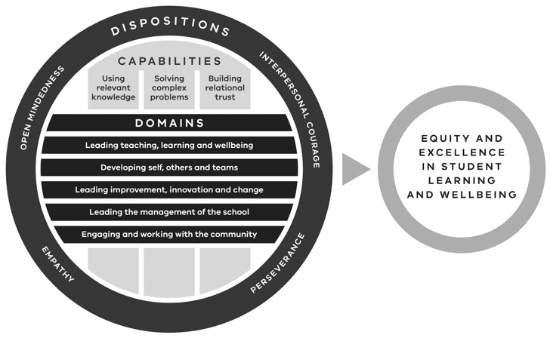

Evaluation
The EEC evaluates the impact of leadership excellence programs through an impact evaluation survey administered to program participants within the final session of their professional learning program. The survey aims to gain insight into participant satisfaction and the impact of Academy professional learning on participant development and practice. The evaluation also assesses other measures of impact from Academy professional learning, including impacts on student outcomes and leadership practice, and seeks a net promoter score.
As part of our public accountability measures, the Academy is required to report against Department Performance Statement (DPS) targets as articulated in the appendix to Victorian Budget 2025/26 Budget Paper No. 3: Service Delivery (BP3). For the 2024–25 financial year, the Academy reported against 2024 calendar year data.
In 2024, the Academy exceeded our DPS targets for impact and satisfaction of leadership excellence professional learning. The proportion of participants reporting a ‘significant’ or ‘highly significant’ impact of the Academy’s professional learning on their own development was 86% (target: 78%) and 87% the proportion of participants reporting satisfaction with the program was 87% (target: 82%).
Quantitative evidence further demonstrates the impact of the Academy’s leadership excellence programs. Of those surveyed:
- 90% reported that the professional learning resulted in a positive contribution to developing self, others and teams
- 82% reported that the professional learning resulted in a positive contribution to leading teaching, learning and wellbeing
- 87% reported the professional learning resulted in a positive contribution to leading the management of the school
- 86% reported that the professional learning resulted in a positive contribution to leading school improvement, innovation and change
- 77% reported that the professional learning contributed to improved student learning and wellbeing outcomes in their school
- 76% reported that the professional learning resulted in a positive contribution to engaging and working with the community.
The Academy has commissioned Deloitte Access Economics to undertake an independent, longitudinal evaluation of the VAPA that is both formative – providing timely insights for program improvement – and summative. Evaluation during 2023–24 and 2024–25 indicated that the VAPA has been successfully implemented, is achieving significant throughput and is highly valued by stakeholders. The evaluation confirmed that the diversity of candidates undertaking the assessment reflects the diversity of the school system.
The Academy has also commissioned Deloitte Access Economics to undertake an independent evaluation of the literacy and numeracy suite of programs (the suite). The evaluation explores the extent to which the suite has an impact at the system level and school level and on participant perceptions of their students’ learning outcomes. It also generates evidence, insights and evaluative conclusions and makes recommendations to further improve the suite. In 2024, the evaluation found that the suite supported improvements to literacy and numeracy instruction at the classroom, whole-school and system levels, with participants receiving professional learning that is relevant for their day-to-day classroom practices and school improvement priorities.
Responses from impact surveys demonstrate the positive impact that Academy leadership excellence programs have on teaching and leadership development. They highlight that following participation in Academy programs, participants are better able to contribute to school and system improvement and to improve student learning outcomes.

Principals in Residence, Leadership Excellence Division
PiRs support the work of the Leadership Excellence Division by facilitating programs such as Leading Quality Conversations and Inspire, and by providing professional learning focused on the ALEF. They also provide subject matter expertise and a school lens over program design, development and delivery.
PiRs support stakeholder engagement and program provider interactions, and have input into thought leadership activities such as podcasts and impact stories.
DE draws on the expertise of PiRs for a range of projects related to leadership, teaching and learning, assessment and policy development. They are also an important conduit between the Academy and DE regions, areas and networks. Ten PiRs support the Leadership Excellence Division across the Middle Leader Programs, Professional Learning Partnerships VAPA, Pathway to Principalship and Principal Programs teams.

Evidence of positive impact
The evaluations generated evidence of positive impact. Below are examples of qualitative feedback from leadership excellence program evaluations.
“All of these programs at the Academy hold the mirror up to show you yourself… It’s an atmosphere, a privileged environment, and I’m so grateful to be part of it. I don’t think I could be nearly as effective without having done those programs, and to be honest I’m not even sure I would have tried. The Academy highlights professionalism and standards, and weaves us into a whole to support young people, and it’s so exciting.”
Principal Mentoring participant
Academy objective: To improve outcomes for students through the provision of specialised teaching and leadership excellence programs for exceptional teachers and school leaders
“Evolve reminded me to keep students front and centre of all the decisions that I make. [The program] keeps you current in terms of the needs of students, and it focuses you on continual improvement.”
Evolve: New Principals participant
“I would say there’s definite changes in teacher practice that students can identify greater student awareness of self-regulated learning. and that it encompasses awareness of parents around what self-regulated learning is and the school’s desire to support their students to develop better self-regulated learning skills.”
Unlocking Potential: Principal Preparation participant
Academy objective: Provide a dedicated pathway for established exceptional teachers to contribute to school system improvement
“Participating in the Academy’s professional learning helped me grow as a leader, communicate more effectively, advocate for change, and bring innovative practices to my school. I am better equipped to influence both local and systemic changes within the education sector.”
Unlocking Potential: Principal Preparation participant
Academy objective: To improve the quality of school leadership
“Through the program I have learnt to be more strategic. In working with my mentor, I was able to identify that everything in a school is not the responsibility of the principal. I realised that I needed to allow others in my school to drive things and lead the improvement.”
Evolve: New Principals participant

“[The program] has reinforced … how important it is to be an instructional leader, how important it is to demonstrate my own growth as well and to be in the learning pit with everybody else. Being reflective of my own leadership ability and where I need to enhance those skills as well. So, it’s strengthened my understanding and strengthened my approach.”
Leading Quality Conversations participant

Academy regional centres

The Academy has 7 regional centres – in Bairnsdale, Ballarat, Bendigo, Geelong, Mildura, Moe and Shepparton. The Academy began operation of the permanent Bendigo site in October 2024.
The Academy regional centres support all the Academy objectives. In particular, the presence of regional centres contributes significantly to ensuring equity of access to high-quality professional learning for teachers and school leaders in regional and rural areas by reducing barriers to professional learning – for example, by significantly reducing travelling time. They help the Academy meet teachers and leaders at their point of need and strengthen networking opportunities by building collective efficacy in local areas.
Regional centres deliver a variety of Academy programs, including:
- leadership excellence programs, delivered in person and tailored to meet local needs
- the TELCs of TEP, enabling local teachers to come together to collaborate and network
- professional learning programs developed in collaboration with local schools and system leaders to align with identified priorities in particular regions
- in 2025 the statewide Mathematics and Numeracy Symposium: Government Schools engaged 544 educators across all Academy sites and an additional site in Wangaratta simultaneously via technology and local facilitators at each site. The symposium deeply engaged participants in the implementation of mathematics and numeracy improvement strategies in alignment with the revised VTLM 2.0. A total of 274 teachers and leaders participated at the 7 Academy regional centres and the additional site in Wangaratta, in addition to 270 teachers and leaders attending from metropolitan Melbourne.
- the Regional Division leads the annual Government Schools Principals Conference for up to 4,000 principals, assistant principals and system leaders to learn, network and plan together. In the 2024–25 reporting year, due to the 2024 event taking place in late July 2024 and the 2025 event taking place in June 2025, the Academy led two successful Government Schools Principals Conferences.
In addition to the events outlined above, each Academy regional centre hosts numerous meetings and events for DE teams, schools and staff from across all sectors, professional associations and others to support educational activities in their region.

Evaluation
The presence of Academy regional centres has a significant impact on increasing access to professional learning across regional and rural Victoria. Evidence to support this has been gathered from program participants through their engagement in impact interviews. A total of 64 impact interviews were conducted by Academy regional centres conducted and analysed by the EEC in 2024–25.
Findings highlight that the Academy regional centres play a pivotal role in enhancing professional learning for educators, creating a powerful environment for leadership development, positively impacting student outcomes and increasing community engagement. Impact interviews demonstrate that professional learning is now more accessible to teaches and leaders in regional and rural areas due to the Academy’s presence in regional Victoria, particularly for those with carer responsibilities and family commitments. It is also evident that professional learning empowers educators to take valuable learning back to their schools, facilitating a flow-on effect that has positively impacted participants’ teaching practices and leadership approaches, and those of their colleagues in schools.
According to the findings, the physical presence of the Academy in regional locations is also a key factor in reinforcing the important status of the teaching profession. Educators noted that the Academy’s facilities give credibility to their work, providing tangible recognition of the value of their professional learning.
The following responses from Academy program participants demonstrate how the Academy is meeting 3 of our legislative objectives through the work of the Regional Division.
Academy objective: To improve outcomes for students through the provision of specialised teaching and leadership excellence programs for exceptional teachers and school leaders
“The more we learn [as teachers], the more impact we can have on students’ learning.”
Program participant, Bairnsdale

“Not only have I already shared what I learnt with some of my colleagues, but I’ve implemented the work into my classroom with amazing results. It’s definitely had a big flow-on effect.”
Teaching of Writing Masterclass with Dr Misty Adoniou participant, Bairnsdale
Academy objective: To increase equity of access to professional learning to lift the quality of teaching across Victoria
“The regional centre has allowed access to high quality targeted learning that is focused on needs. If it was not available regionally, I would probably not have done the course.”
Leading School Improvement participant, Moe
Academy objective: To raise public awareness of the capability and status of teachers and school leaders in the science and practice of teaching
“The design of the Academy spaces and all the staff I’ve interacted with makes me feel like teachers are being recognised as valued professionals and this space is dedicated to their learning. I think it makes teachers feel like what we are learning as teachers is important, and we want you to have those opportunities even if you live 6 hours from Melbourne.”
Program participant, Bendigo

Academy regional centre use
Figure 5 outlines teacher and school leader registration in Academy programs from 2022 to 2024. Academy regional centres opened throughout 2023, with all 7 regional centres operating by the end of 2023, including a temporary centre in Bendigo. Figure 5 shows that Academy professional learning registrations have increased in all DE regional areas since the centres opened.
Figure 5: 2022–24 Academy program registrations in regional centres
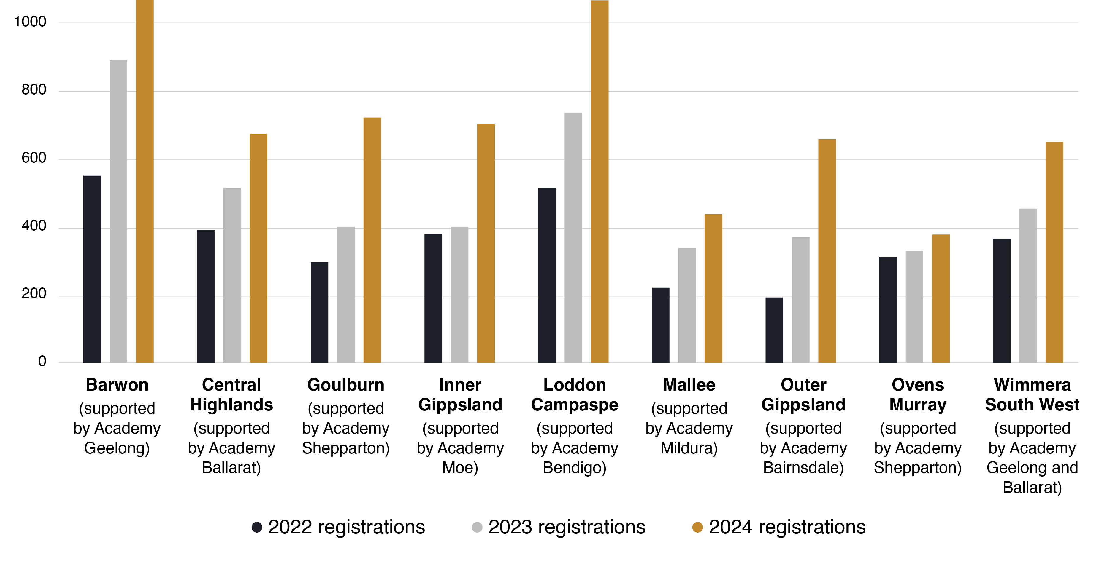

Table 2: Regional centre attendance, 1 July 2024 to 30 June 2025
Stakeholder | Events | Attendees
Academy | 353 | 6,727
Department of Education | 499 | 9,778
Government school | 282 | 3,280
Other | 212 | 3,490
Total | 1,346 | 23,275
Note: Attendance is for any activity, not limited to professional learning (for example, school improvement team,
school planning, interviews or coaching).

Strategic plan
The Academy’s Strategic Plan on a Page 2025 is a framework that has been endorsed by the Board.
It is built around the Academy’s legislated objectives (see Objectives and functions, p. 6).
The plan covers the Academy’s vision, mission, objectives, functions, enablers and values.
Figure 6: Academy Strategic Plan on a Page 2025
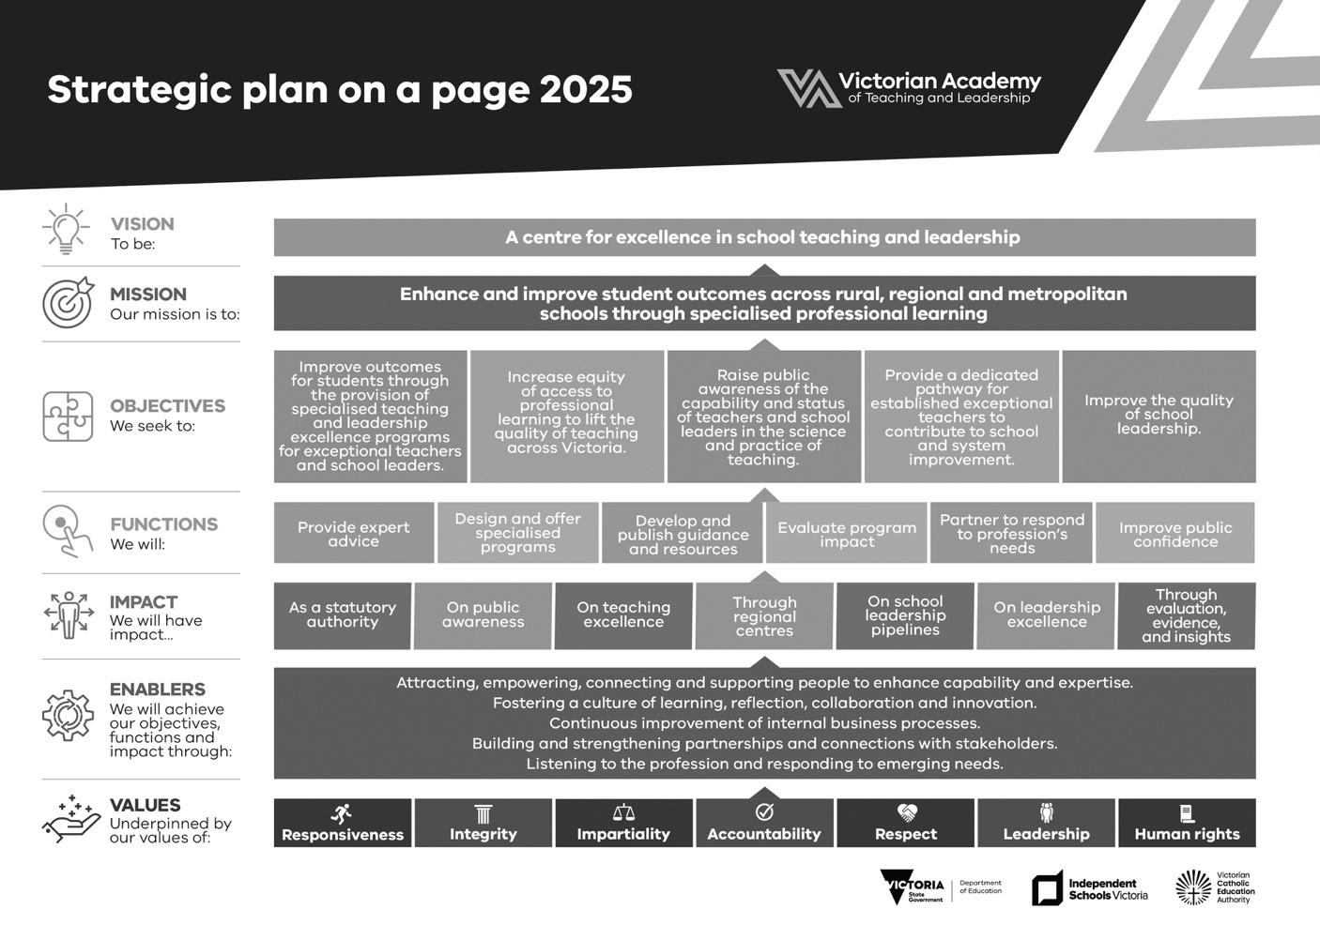

Academy measures of success and indicators and targets (outputs)
Table 3: Measures of success and indicators and targets (outputs)
Performance measures | 2024–25  target | 2024–25  actual¹
Quantity | Number | Number
Number of assistant principals participating in leadership development programs at the Victorian Academy of Teaching and Leadership (day length or longer) | 700 | 1,144
Number of principals participating in leadership development programs at the Victorian Academy of Teaching and Leadership (day length or longer) | 1,100 | 1,215
Number of teaching service staff who are not principals or assistant principals participating in leadership development programs at the Victorian Academy of Teaching and Leadership (day length or longer) | 2,400 | 3,742
Number of participants in the Teaching Excellence Program | 400 | 438
Number of teaching service staff participating in short-form Academy professional learning | 1,800 | 4,362
Quality | Percent | Percent
Proportion of participants (all programs) who are satisfied with the Victorian Academy of Teaching and Leadership’s professional learning and development training | 82 | 87
Proportion of participants rating (all programs) the impact of the Victorian Academy of Teaching and Leadership’s professional learning on their own development and practice at or above ‘significant’ | 78 | 86

. The Academy’s output performance measures are calculated on a calendar-year basis. The 2024–25 actual is reported using data from the 2024 calendar year.

Financial summary
Table 4: Financial summary
Financial summary | 12-month period  to Jun 25 | 12-month period  to Jun 24
Total income from transactions | $58,494,536 | $58,189,209
Total expenses from transactions | $52,600,004 | $51,697,766
Net result from transactions | $5,894,532 | $6,491,443
Net result for the period | $5,894,532 | $6,491,443
Net cash flow from operating activities | $848,028 | $708,677
Total assets | $35,624,925 | $27,531,608
Total liabilities | $7,019,387 | $4,820,602

Significant changes in financial position – balance sheet
There was a $7.4 million increase in receivables and a $5.9 million increase in accumulated surplus due to the positive net result in transactions for the 2024–25 financial year.

Significant changes in financial position – operating statement
For the 2024–25 financial year, the Academy recorded a favourable budget variance of $5.9 million.

Significant events affecting the Academy that occurred after balance date
There were no significant events after 30 June 2025 that affected the Academy’s operations.

Organisational structure

Organisational structure and corporate governance arrangements



The Hon. Ben Carroll MP

Deputy Premier, Minister for Education and Minister for WorkSafe and the TAC
The Hon. Ben Carroll MP was appointed as the Deputy Premier and Minister for Education in October 2023 and as Minister for WorkSafe and the TAC in December 2024.
The Minister for Education is responsible for overseeing Victoria’s Education State reforms and providing education to more than a million Victorian students. This portfolio includes Victorian Government investment in school infrastructure and programs.

Senior leadership


Dr Marcia Devlin AM

Chief Executive Officer

Dr Marcia Devlin AM (PhD GAICD) joined the Academy in 2021 as the inaugural Chief Executive Officer (CEO). Dr Devlin brings more than 30 years of national and international experience in education and an unwavering commitment to continually improve the quality of teaching and learning, ensure the concept of ‘excellence’ encompasses equity, and strengthen educational leadership. In 2023, Dr Devlin was appointed a Member of the Order of Australia (AM) for her significant contributions to education and gender equity.
Dr Devlin began her education career as a primary school teacher before moving into the tertiary sector. She is now a globally recognised expert in education, educational equity and leadership, an Honorary Professor at Macquarie University and a registered psychologist. Her PhD examined the impact of professional learning and coaching on university teaching and student outcomes.
Prior to her appointment at the Academy, Dr Devlin was senior deputy vice-chancellor at Victoria University where she remains an Adjunct Professor. Before that, she held executive and senior leadership roles at Federation University Australia, RMIT University, Deakin University and the University of Melbourne. Internationally recognised for her expertise in education, she has given more than 115 keynote and invited addresses in 10 countries, has won more than $6 million in research funding, and has hundreds of academic, professional and media publications to her name.
Dr Devlin is a Trust member of the Queen Victoria Women’s Centre and an elected Lifetime Fellow of the Society for Research into Higher Education based in the United Kingdom. She is an appointed Specialist with the Hong Kong Council for Accreditation of Academic and Vocational Qualifications. She also serves on the advisory board of the journal Student Success.
Dr Devlin was a non-executive director on the board of Melbourne Polytechnic as well as Chair of its Education Quality Committee. She is a board member and committee chair of the Victorian Curriculum and Assessment Authority (VCAA). During the reporting period, Dr Devlin also served as Interim CEO of the VCAA (November 2024 to January 2025) to oversee delivery of the 2024 Victorian Certificate of Education results.



Peter Saffin

Chief Operating Officer
Peter Saffin joined the Academy in 2021 as the inaugural Chief Operating Officer (COO). He works closely with the CEO to lead and oversee the Academy’s operational accountabilities. This includes aligning strategy, budget, business planning, compliance and reporting with the government’s policy and delivery priorities and the Academy’s legislated objectives.
Peter brings to the Academy a wealth of experience in education, governance and operations across schools, corporate and not-for-profit environments. Peter commenced his career as a secondary school teacher and leader in Australia and New Zealand. After teaching, Peter moved into educational publishing, where he led teams producing award-winning resources and learning platforms for use in Australia and overseas. He managed various operational teams and was Managing Director of Australia and New Zealand for Macmillan Education Australia.
Prior to joining the Academy, Peter was CEO of the Mathematical Association of Victoria, where he increased funding and improved sustainability. A large focus of Peter’s work was on partnerships, professional learning and creating impact for the teaching profession. In 2024, Peter was made an Honorary Life Member in recognition of his contribution to the association and mathematics education in Victoria. Peter has served on several boards in the not-for-profit sector.
During the reporting period, Peter was Acting CEO (August 2024 to September 2024 and November 2024 to February 2025).


Tyron Paspa

Director, Regional Division
As Director of the Regional Division, Tyron leads the Academy’s 7 regional centres, working in partnership with stakeholders across Victoria to identify professional learning priorities and deliver high-quality, accessible programs tailored to the needs of educators in regional and rural communities.
Tyron brings more than a decade of public sector experience spanning early childhood and school education policy, investment strategy, infrastructure, and project and program management. He has held roles at DE, Regional Development Victoria, Corrections Victoria and the Department of Health.
In 2021, Tyron was the Project Director responsible for establishing the Victorian Academy of Teaching and Leadership. Earlier in his career, he played a foundational role at the Victorian School Building Authority (VSBA), where he worked with government to secure more than $10 billion in education infrastructure investment and led implementation of the Asset Management Reform initiative.
Tyron is known for his passion for good public administration, his collaborative approach, and his commitment to delivering public value through strategic leadership and deep engagement with the education workforce.
During the reporting period, Tyron also served as Acting Director, Business Services Division (March–April 2025), COO (November 2024) and CEO (November 2024).


Megan Knowles

Director, Business Services Division
As the inaugural Director of the Academy’s Business Service Division, Megan is responsible for the provision of the Academy’s corporate and business services as well as business continuity. These functions include people, capability and culture, finance, facilities management, technology, procurement, strategic projects, risk, audit and the Academy’s project management office. These functions allow the Academy to provide high-quality professional learning while supporting and acquitting all requirements of a statutory authority.
Originally a youth worker, Megan moved into public health and health promotion in early childhood development, where she developed her passion for education.
Megan worked as a classroom teacher and learning community manager before she joined DE in the implementation of key reform priorities.
During Melbourne’s second COVID-19 wave, Megan joined the then-Victorian Department of Health and Human Services, helping to reopen schools and supporting the design and development of improved contact tracing. In 2020, she joined the former Bastow Institute of Educational Leadership where she established the Business Priorities Unit before taking up her role in the Academy.
During the reporting period, Megan was Acting COO (November 2024 to January 2025 and April 2025).


Gerard O’Shaughnessy

Director, Academy Services Division
A former secondary school teacher in psychology and drama, Gerard has significant school leadership experience in Australia and internationally as head of school and assistant principal. As a school leader, Gerard has led many school improvement initiatives, ranging from teaching and learning and inclusion approaches, to operational enhancements. Gerard has a passion for equity and excellence in education, particularly for students with disabilities and additional needs.
Gerard previously managed DE’s Student Voice and Academic Excellence unit before moving into learning design and innovation. He also managed establishment of the Centre for Higher Education Studies.
Gerard joined the Academy in 2022, successfully establishing and leading the participant and program support function. Gerard holds a master’s degree in educational leadership and management. He remains committed to continuous learning and professional growth.
Under Gerard’s leadership, the Academy Services Division provides support and services in evaluation and evidence, learning development and innovation, and communications and marketing. It coordinates program support and the Academy’s participant experience.



Emily Benson

Director, Teaching Excellence Division
Emily Benson began her career in education in 2007, joining DE as a primary school teacher working her way up to assistant principal. Emily has held educational leadership positions focused on initiatives to enhance student learning outcomes – for example, the Middle Years Literacy and Numeracy Support initiative and the Tutor Learning Initiative. With a strong commitment to student wellbeing, Emily has also served as Manager of Health, Wellbeing and Specialist Services.
In 2022, Emily joined the Academy’s Regional Division in the role of Manager, Regional Coordination, leading forums and conferences aimed at enriching the professional development of principals and assistant principals and supporting the establishment of the division.
As Director of the Teaching Excellence Division, Emily oversees delivery of the TEP, TIF and Academy Alumni program (formerly the TEP Alumni Network) and across all school sectors to Victoria’s exceptional teachers.


Kendra Parker

Director Leadership Excellence Division
(from Jul 2024)
Kendra Parker brings over 25 years’ experience in school education as a classroom teacher, principal and network leader. Prior to joining the Academy, Kendra was principal of two government primary schools in south-eastern and north-eastern Victoria. She joined the Academy in November 2021, as one of the inaugural Principals in Residence. Kendra is committed to developing leaders at all levels in line with the Academy’s strategic plan.
In her work at the Academy, Kendra has been instrumental in leading the development and delivery of the Academy’s Leadership Excellence Framework and associated professional learning and resources. She has also provided expertise and insights into the design, development and provision of many Academy programs. Kendra is passionate about the purpose of education being to equip students with the knowledge, skills and characteristics to be productive and successful.
Along with her teaching career, Kendra has worked in the disability sector and as a senior policy advisor and business analyst at Queensland Rail. She holds degrees in teaching, special education and public policy. As a lifelong learner, Kendra leads the Leadership Excellence Division with passion and commitment and a belief in the importance of leadership and professional learning.

Board
The Board sets the strategic direction for the Academy
and is accountable to the Minister for Education.

Current Board



Dr Toni Meath

Chair
Reappointed as Chair of the Board on 1 April 2025, Dr Toni Meath GAICD FACEL is Principal of Melbourne Girls Grammar. She is an accomplished leader with deep knowledge of the Victorian education sector. Dr Meath’s work in education innovation has been published nationally and internationally.
Dr Meath was principal of the Mac.Robertson Girls’ High School and founding assistant principal of Nossal High School, Victoria’s first co-educational select-entry high school.
Until her appointment as the inaugural Chair of the Academy Board, Dr Meath was a member of the VCAA Board.
During the reporting period Dr Meath was on approved leave, from October 2024 to
January 2025.


Martin Keogh

Nominee of the Victorian Catholic
Education Authority
Martin Keogh is General Manager of Learning and Teaching at Diocese of Sale Catholic Education Limited. He is responsible for the strategic direction and support of Catholic schools, both metropolitan and regional, located in the south-eastern region of Victoria.
Mr Keogh’s career spans various educational settings, encompassing rural, regional and metropolitan schools, where he has served as a teacher, school leader and principal. He has extensive governance experience, having served as director and chair on several not-for-profit boards.


Christine Lucas

Nominee of Independent Schools Victoria (from 1 Apr 2025)
Christine Lucas is Head of School Services at Independent Schools Victoria. An accomplished educational leader, Christine has had a successful career in school-based, jurisdictional and national senior roles, including as vice-principal of Hillcrest Christian College, principal of Brindabella Christian College and senior roles in the Australian Government departments of Education and Community Services. Christine’s expertise includes leading and delivering excellence in strategic and operational areas, learning and teaching improvement, student and staff wellbeing, leadership development, human resources, financial management and strong community partnerships. She has a Bachelor of Education and a Master of Education from the University of Canberra.
Christine was appointed to the Academy Board by the Governor in Council on 1 April 2025.


Chris Thompson

Nominee on behalf of the Secretary of DE (from Jan 2025)
Chris Thompson is Regional Director of DE's South-Western Victoria Region. In this role he provides an interface between the government, DE’s central office, and schools and service providers, ensuring that learners move seamlessly through the government education system and that improved learning and wellbeing outcomes for all Victorians are realised.
Chris has held a number of other executive roles at DE, focusing on education policy relating to languages, sport and multicultural, Koorie and rural students. He has also worked at the Victorian Government departments of Premier and Cabinet, Planning and Community Development and Human Services.
Chris was nominated to the Board by the Secretary of DE in January 2025.


Lucy Amon

(from 26 Nov 2024)
Lucy Amon is Head of First Nations Strategy and Engagement at North Melbourne Football Club. She has held roles in both the government and independent sectors in Victoria, as an Indigenous programs coordinator, and as a classroom teacher. Lucy has also been a First Nations education consultant in the private sector and is a former member of the Education Committee of the Board of Melbourne Indigenous Transition School.
Lucy was appointed to the Academy Board by the Governor in Council on 26 November 2024.


Professor Chris Walsh

(from 1 Apr 2025)
Professor Chris Walsh is the Chief Academic Officer and Dean of Victoria University Online. He is an extensively published academic with broad experience as an executive leader at universities such as Victoria University, James Cook University, Torrens University Australia and the Open University. Professor Walsh is a board member of Violence Prevention Australia and Bridges Across Borders Southeast Asia Community Legal Education Foundation.
He has a strong background in audit and risk management, and extensive knowledge and experience working with special needs, disadvantaged and marginalised communities.
Professor Walsh holds a PhD in Education, an MBA, Master of Education, Master of Science and a Bachelor of Arts.
Professor Walsh was appointed to the Academy Board by the Governor in Council on 1 April 2025.


Nicole Pollard

(from 1 Apr 2025)
Nicole Pollard is Principal of Marlo Primary School. She is a passionate regional school leader who has a deep understanding of the unique challenges faced by young people in regional Victoria. She is a Network Executive Member. Notably, Nicole has worked with a Senior Education Improvement Leader and Network Executive to analyse Network data and develop and implement a 3-year plan aimed at improving health and wellbeing data of students across all schools in the area. She holds a Master of Education, Postgraduate Certificate in Educational Leadership and a Bachelor of Education. Nicole lives and works in regional Victoria.
Nicole was appointed to the Academy Board by the Governor in Council on 1 April 2025.

Former members of
the Board during the reporting period

Chris Wardlaw

Acting Chair (12 Nov 2024 to 4 Jan 2025)
Chris Wardlaw PSM is Deputy Chair of the Australian Institute for Teaching and Leadership. He is also an Independent Member of the School Policy and Funding Advisory Council and a Facilitator for Whalan Learning Group. Mr Wardlaw was Chair of the VCAA from 2013 to 2023. In 2013, Mr Wardlaw was awarded a Public Service Medal and in 2014, he was made a Fellow at Monash University.
Mr Wardlaw was appointed to act as Chair of the Board by the Minister for Education from 12 November 2024 to 4 January 2025.

Kieren Noonan

Nominee of Independent Schools Victoria (until 15 Oct 2024)
Kieren Noonan is the former Head of Innovation and Learning at Independent Schools Victoria. He is an innovative education professional with extensive experience in educational leadership and strategically delivering innovative products, solutions and initiatives.
Kieren’s resignation from the Board was accepted by the Governor in Council on 15 August 2024.

Judith Downes

Chair of Audit and Risk Committee
(until 31 Mar 2025)
Judith Downes has worked in senior executive and non-executive roles in banking, finance, accounting, funds management, life insurance and property. She was Director of the Australian Mathematical Science Institute and a member of the Financial Reporting Council.
Judith’s term on the Board concluded on 31 March 2025.

Professor Viv Ellis

(until 31 Mar 2025)
Professor Viv Ellis is Dean of the Faculty of Education at Monash University. He has worked with government agencies and non-government organisations across the United Kingdom, Europe, Asia and Australia, most recently on Norwegian Government reforms to upper primary and lower secondary initial teacher education.
Viv’s term on the Board concluded on 31 March 2025.

Dr David Howes

Nominee on behalf of the Secretary of DE (until Jan 2025)
Dr David Howes is the Deputy Secretary, Schools and Regional Services at DE. David’s appointment as the nominee of the Secretary concluded in January 2025.

Audit and Risk Committee
The Audit and Risk Committee is appointed by the Board in accordance with the Standing Directions 2018 of the Minister for Finance under Victoria’s Financial Management Act 1994 (FM Act).
The Audit and Risk Committee assists the Board in fulfilling its oversight and governance responsibilities and obligations under the FM Act.
In accordance with the FM Act and associated Standing Directions 2018 of the Minister for Finance, the Audit and Risk Committee monitors:
- financial reporting
- internal controls and risk management
- internal audit function
- external audit function
- compliance with the FM Act, laws and regulations
- remedial action of audit issues.
Audit and Risk Committee members are:
- Kathryn Brown, Chair (from 27 May 2025)
- Martin Keogh (from 16 October 2024)
- Professor Chris Walsh (from 13 May 2025)
- Christine Lucas (from 13 May 2025)
Former members of the Audit and Risk Committee during the reporting period were:
- Judith Downes, Chair (until 31 March 2025)
- Kieren Noonan (until 15 October 2024)
- Professor Viv Ellis (until 31 March 2025)
- Ella McPherson (until 18 March 2025)

Organisational structure
Figure 7: Academy organisational structure at 30 June 2025

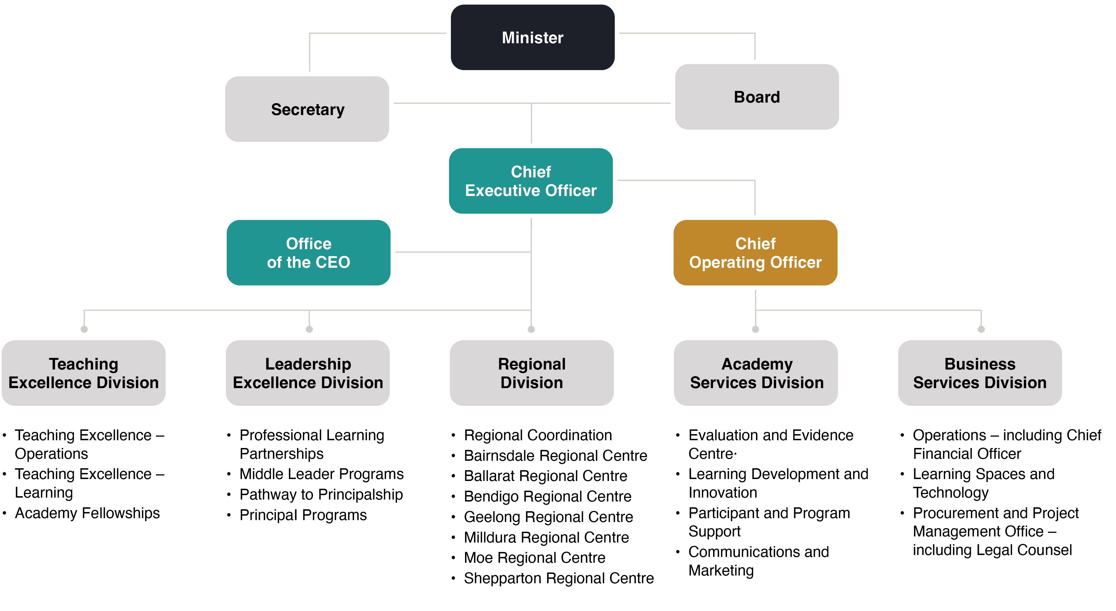

Occupational health and safety

The Academy’s occupational health and safety (OHS) objectives are to:
- prevent injury or illness from occurring in the workplace
- maintain the health and wellbeing of all staff
- comply with all statutory requirements of Acts and Regulations, codes of practice
and standards.
To fulfil these objectives, the Academy:
- proactively ensures that the workplace is safe and without risk to health
- assists the Academy’s OHS representatives to maintain their knowledge and be informed of any changes to Victoria’s Occupational Health and Safety Act 2004
- applies OHS policies, procedures and practices, which include active participation on DE’s Education Precinct OHS Committee.
Key OHS initiatives and activities in 2024–25 included:
- occupying an additional regional Academy building, which included the establishment of all site-related OHS arrangements, completion of building risk assessments and activation of all Essential Safety Measures compliance requirements.
- reviewing and confirming the Academy’s compliance with the Worksafe compliance code for first aid in the workplace across our sites.
- training fire wardens, completing practical evacuation drills and holding meetings of the Emergency Control Organisation across all Academy sites.
The Academy operates within DE’s infrastructure and controls. As such, it complies with DE’s OHS policies and procedures, including reporting requirements. DE’s Annual Report 2024–25 contains reporting on incidents, hazard management and workers’ compensation relating to the Academy.

Employment and conduct principles

Our culture

Employee Value Proposition
The Academy’s Employee Value Proposition, developed in collaboration with Academy staff, is presented below.
At the Academy, we are passionate about meaningful and exciting work that has an impact on education and student outcomes.
Our shared purpose is to create and offer evidence-informed professional learning programs, events and initiatives designed to take Victoria’s highly skilled teachers and school leaders from great to exceptional and advance the quality and status of teaching and school leadership.
We care about the quality of our work, demonstrate collective responsibility for continuous improvement and support each other to do the very best we can every day to achieve our goals.
The Academy is a learning organisation that provides opportunities for employees to grow.
We have a positive culture that we are building together, where people feel supported, valued and heard.

People Matter and Pulse surveys
The Academy is committed to measuring, understanding and proactively supporting our culture. The Academy uses the results of the People Matter survey to monitor and continually improve our approach to supporting staff and enhancing workplace culture. Staff have indicated that they believe the Academy makes improvements based on the survey results, and this trust reflects many aspects of the Academy’s approach to people matters and taking action. The results of the People Matter survey in 2024–25 were very positive. Feedback was used to co-develop actions and strategies with staff around workload management, wellbeing, and learning and development.

Workforce data

Public sector values and employment principles

Public sector values
The Academy adopts the public sector values set out in the Code of Conduct for Victorian Public Sector Employees. These values define what is important to the Academy’s work and
underpin our employees’ interactions with colleagues, participants, stakeholders, suppliers
and the broader education sector community.
The Academy uses DE’s suite of VPS values materials to support consistent interpretation and a strong connection with the public sector values in our everyday work.
Figure 8: Public Sector Values


Code of conduct
The Code of Conduct for Victorian Public Sector Employees (the Code) is adopted by the Academy and prescribes standards of behaviour expected of the Academy’s employees, including the VPS values.
The Code is binding on Academy employees. The Academy supports the Code in many practices, such as declaring conflicts of interest, management of gifts, benefits and hospitality, and the prevention and reporting of unethical behaviour. The Academy leverages many of the department’s tools and resources to support consistent adherence and implementation of the Code.

Comparative workforce data
Table 5: Comparative workforce data
 | Jun 25 |  |  |  |  |  |  |  | Jun 24
 | All employees |  | Ongoing |  |  | Fixed term/casual |  |  | All employees |  |  |  | Ongoing |  |  | Fixed term/casual
 | Headcount | FTE | Full-time | Part-time | FTE |  | Headcount | FTE |  | Headcount | FTE | Full-time |  | Part-time | FTE | Headcount | FTE
Gender
Female | 91 | 86.5 | 46 | 12 | 55.2 |  | 33 | 31.3 |  | 94 | 90.8 | 35 |  | 9 | 41.9 | 50 | 48.9
Male | 35 | 34.8 | 23 | 1 | 23.8 |  | 11 | 11.0 |  | 35 | 34.8 | 16 |  | 1 | 16.8 | 18 | 18.0
Self-described | 2 | 2.0 | 2 | - | 2 |  | - | - |  | 1 | 1 | - |  | - | - | 1 | 1.0
Age
15–24 | 9 | 8.8 | - | - | - |  | 9 | 8.8 |  | 9 | 8.8 | - |  | 1 | 0.8 | 8 | 8.0
25–34 | 24 | 23.2 | 10 | 2 | 11.6 |  | 12 | 11.6 |  | 23 | 22.8 | 9 |  | 1 | 9.8 | 13 | 13.0
35–44 | 48 | 45.9 | 30 | 5 | 33.8 |  | 13 | 12.1 |  | 54 | 51.8 | 20 |  | 5 | 23.5 | 29 | 28.3
45–54 | 35 | 33.5 | 21 | 5 | 24.7 |  | 9 | 8.8 |  | 30 | 29.4 | 17 |  | 2 | 18.8 | 11 | 10.6
55–64 | 12 | 11.9 | 10 | 1 | 10.9 |  | 1 | 1.0 |  | 14 | 13.8 | 6 |  | 1 | 6.8 | 7 | 7.0
65+ | - | - | - | - | - |  | - | - |  | - | - | - |  | - | - | - | -
Classification
VPS 1–6 grades | 125 | 120.3 | 68 | 13 | 78.0 |  | 44 | 42.3 |  | 127 | 123.6 | 49 |  | 10 | 56.7 | 68 | 66.9
VPS 1 | - | - | - | - | - |  | - | - |  | - | - | - |  | - | - | - | -
VPS 2 | 6 | 5.8 | - | - | - |  | 6 | 5.8 |  | 6 | 6.0 | - |  | - | - | 6 | 6.0
VPS 3 | 13 | 12.6 | 8 | 1 | 8.8 |  | 4 | 3.8 |  | 14 | 13.6 | 5 |  | 1 | 5.8 | 8 | 7.8
VPS 4 | 34 | 32.8 | 14 | 3 | 16.2 |  | 17 | 16.6 |  | 37 | 36.0 | 12 |  | 2 | 13.4 | 23 | 22.6
VPS 5 | 48 | 46.2 | 29 | 4 | 32.1 |  | 15 | 14.1 |  | 44 | 42.9 | 18 |  | 4 | 21.2 | 22 | 21.7
VPS 6 | 24 | 22.9 | 17 | 5 | 20.9 |  | 2 | 2.0 |  | 26 | 25.1 | 14 |  | 3 | 16.3 | 9 | 8.8
Senior employees | 3 | 3.0 | 3 | 0 | 3.0 |  | 0 | 0.0 |  | 3 | 3 | 3 |  | 0 | 3 | 0 | 0
Senior Technical Specialist | - | - | - | - | - |  | - | - |  | - | - | - |  | - | - | - | -
Executives | 3 | 3.0 | 3 | - | 3.0 |  | - | - |  | 3 | 3.0 | 3 |  | - | 3.0 | - | -
Total employees | 128 | 123.3 | 71 | 13 | 81.0 |  | 44 | 42.3 |  | 130 | 126.6 | 52 |  | 10 | 59.7 | 68 | 66.9

Notes:
- ‘Headcount’ refers to the number of people employed. Each person counts as an employee regardless of the number of hours they are engaged to work.
- ‘Casual’ refers to a person who is subject to clause 35 of the Victorian Public Service (VPS) Enterprise Agreement 2024 ‘Casual Employees – Loading’ or similar clauses in other relevant agreements. It includes persons employed on a sessional basis where provided for under an applicable industrial agreement.
- ‘VPS’ refers to the Victorian public sector.
- ‘FTE’ refers to full-time equivalent.
- Age of staff is calculated at 30 June each year.
- The category ‘VPSG2’ includes graduate recruits.
- The Academy did not have any instances of employees acting as senior employees in a long-term arrangement.
Table 6: Teaching service workforce
 | Jun 25 |  |  |  |  |  |  |  | Jun 24
 | All employees |  | Ongoing |  |  |  | Fixed term/casual |  | All employees |  |  | Ongoing |  |  | Fixed term/casual
 | Headcount | FTE |  | Full-time | Part-time | FTE | Headcount | FTE | Headcount | FTE | Full-time |  | Part-time | FTE | Headcount | FTE
Gender
Female | 17 | 16.6 |  | 15 | 2 | 16.6 | - | - | 17 | 16.8 | 15 |  | 1 | 15.8 | 1 | 1.0
Male | 14 | 14.0 |  | 14 | - | 14.0 | - | - | 8 | 8.0 | 8 |  | - | 8.0 | - | -
Self-described | - | - |  | - | - | - | - | - | - | - | - |  | - | - | - | -
Age
15–24 | - | - |  | - | - | - | - | - | - | - | - |  | - | - | - | -
25–34 | 3 | 3.0 |  | 3 | - | 3.0 | - | - | 2 | 2.0 | 2 |  | - | 2.0 | - | -
35–44 | 13 | 12.8 |  | 12 | 1 | 12.8 | - | - | 9 | 8.8 | 7 |  | 1 | 7.8 | 1 | 1.0
45–54 | 9 | 8.8 |  | 8 | 1 | 8.8 | - | - | 6 | 6.0 | 6 |  | - | 6.0 | - | -
55–64 | 6 | 6.0 |  | 6 | - | 6.0 | - | - | 8 | 8.0 | 8 |  | - | 8.0 | - | -
65+ | - | - |  | - | - | - | - | - | - | - | - |  | - | - | - | -
Classification
Executive Class | 4 | 4.0 |  | 4 | - | 4.0 | - | - | 4 | 4.0 | 4 |  | - | 4.0 | - | -
Principal Class | 13 | 12.6 |  | 11 | 2 | 12.6 | - | - | 8 | 7.8 | 7 |  | 1 | 7.8 | - | -
Teacher Class | 13 | 13.0 |  | 13 | - | 13.0 | - | - | 12 | 12.0 | 12 |  | - | 12.0 | - | -
Education Support Class | 1 | 1.0 |  | 1 | - | 1.0 | - | - | 1 | 1.0 | - |  | - | - | 1 | 1.0
Total employees | 31 | 30.6 |  | 29 | 2 | 30.6 | - | - | 25 | 24.8 | 23 |  | 1 | 23.8 | 1 | 1.0

Notes:
- ‘Principal Class’ comprises principals, assistant principals and liaison principals.
- ‘Teacher Class’ comprises leading and classroom teachers, and paraprofessionals.
- The Academy’s employee selection processes ensure that applicants are assessed and evaluated fairly and equitably on the basis of the key selection criteria and other accountabilities.

Workforce inclusion policy

The Academy provides an inclusive working environment, and we value equal opportunity and diversity. The voices of staff and members of the diverse array of communities we work with help to shape our organisation. The Academy’s workforce reflects the communities we serve. The Academy’s commitment to deepening diversity and inclusion improves active participation. Our staff feel a sense of belonging at work and are encouraged to maintain their uniqueness. Staff are valued and supported, regardless of their age, ethnicity, race, abilities, religion, socioeconomic status, culture, sex, sexual orientation or gender identity.
The Academy acknowledges that due to historical and current barriers to disclosing identities, staff may choose to not disclose certain information. As a result, targets or quotas are not always a useful way to assess the Academy’s progress.
The Academy’s drive to promote and support diversity, inclusion and gender equality is best demonstrated by our actions. These include, for example, providing participant scholarships for school staff who identify as First Nations, deep engagement with DE’s work around gender equity, offering advice and support on disability inclusion to Academy program providers, and working to embed First Nations perspectives in the TEP.
The Academy is also guided by, and contributes to, DE diversity and inclusion policies, plans and strategies, including:
- 2023–27 Cultural diversity plan
- 2022–25 Gender equality action plan
- 2022–26 Aboriginal inclusion plan.
The Academy also engages in DE committees and working groups, including the Workforce Diversity and Inclusion Working Group, Aboriginal Employment Plan Working Group and Integrity Leadership Committee.

Employment principles (merit and equity)
The Academy is committed to applying the following employment principles as outlined in
Section 8 of Victoria’s Public Administration Act 2004:
- employment decisions are based on merit
- public sector employees are treated fairly and reasonably
- equal employment opportunity is provided
- human rights as set out in the Charter of Human Rights and Responsibilities Act 2006 are upheld
- public sector employees have a reasonable avenue of redress against unfair or unreasonable treatment
- in the case of public service bodies, the development of a career public service is fostered.
The Academy’s employee selection processes ensure that applicants are assessed and evaluated fairly and equitably without discrimination on the basis of the key selection criteria and other accountabilities.

Executive data
For the 12-month period ending 30 June 2025, the Academy had 3 staff members classified as executive.
Their salaries are shown in Table 7.
Table 7: Academy executive data
Annualised total salary as at 30 June 2025
Income band (salary) | Executives
<$160,000
$160,000–$179,999
$180,000–$199,999
$200,000–$219,999
$220,000–$239,999
$240,000–$259,999 | 1
$260,000–$279,999
$280,000–$299,999
$300,000–$319,999 | 1
$320,000–$339,999
$340,000–$359,999
$360,000–$379,999
$380,000–$399,999
$400,000–$419,999 | 1
$420,000–$439,999
$440,000–$459,999
$460,000–$479,999
$480,000–$499,999
Total | 3

Note: The salaries reported above are for the full financial year (at the FTE rate).

Other disclosures and attestations

Local Jobs First
Victoria’s Local Jobs First Act 2003, amended in August 2018, brings together the Victorian Industry Participation Policy (VIPP) and the Major Project Skills Guarantee (MPSG) policy, which were previously administered separately. Victorian Government departments and public sector bodies are required to apply the Local Jobs First Policy to projects valued at $3 million or more in metropolitan Melbourne and to statewide projects, or to projects in regional Victoria valued at $1 million or more. The MPSG applies to all construction projects valued at $20 million or more. The MPSG and VIPP guidelines continue to apply to MPSG-applicable and VIPP-applicable projects respectively where contracts were entered into prior to 15 August 2018.

Projects commenced – Local Jobs First Standard
During 2024–25, the Academy commenced two Local Jobs First Standard projects totalling $10.44 million. Both projects were in metropolitan Victoria. The commitments made as part of the Local Jobs First Policy for these projects are as follows:

Project Dragonfly
- An average of 100% of local content has been committed.
- A total of 13.60 jobs have been retained and no new jobs will be created.
- No small to medium enterprise will be engaged as either the principal contractor or as part of the supply chain.

Academy Mentoring Programs
- An average of 97% or above local content has been committed.
- A total of 1.93 jobs have been created, and 0.470 jobs have been retained.

Compliance with Victoria’s Social Procurement Framework
The Academy’s procurement practices are aligned with DE’s Corporate Procurement Framework, including DE’s Social Procurement Strategy.
The Social Procurement Strategy was revised in February 2024 to align with updates to Victoria’s Social Procurement Framework and new implementation guidance from the Department of Government Services.
The Social Procurement Strategy prioritises 5 social procurement objectives:
- opportunities for Victorian Aboriginal people
- opportunities for Victorians with disability
- women’s equality and safety
- opportunities for Victorian priority jobseekers
- environmentally sustainable outputs.
DEs Annual Report 2024–25 has detailed, consolidated metrics on direct spend with social benefit suppliers by DE and its portfolio entities, including the Academy.

Government advertising expenditure
The Academy had no advertising campaigns with a total media spend of $100,000 or greater (exclusive of GST) in the 12-month period ending 30 June 2025.

Consultancy expenditure

Details of consultancies valued at $10,000 or greater
In the 12-month period ending 30 June 2025, the Academy had 4 consultancies where the total fee payable was $10,000 or greater. The total expenditure on these consultancies was $407,613 (excluding GST). Details of individual consultancies are outlined in Table 8.
Table 8: Consultancies $10,000 or greater (excluding GST)
Consultant | Purpose | Total approved project fee | Expenditure  Jul 24 – Jun 25 | Future expenditure
Curio Group | User experience and user interface review of the learning management system | $43,900 | $43,900 | $ –
Deloitte Touche Tohmatsu | Academy evidence strategy | $231,103 | $231,103 | $ –
KPMG Australia | Academy procurement strategy | $69,610 | $69,610 | $ –
Lorraine Mavis Ling | Teaching workforce skills gap research analysis | $63,000 | $63,000 | $ –

Details of consultancies valued at less than $10,000 (excluding GST)
For the 12-month period ending 30 June 2025, the Academy had one consultancy where the total fee payable was less than $10,000. The total expenditure on this consultancy was $9,711 (excluding GST). Details are outlined in Table 9.
Table 9: Consultancies less than $10,000
Consultant | Purpose | Total approved project fee | Expenditure  Jul 24 – Jun 25 | Future expenditure
Frontier Economics | Fees and subsidies review | $9,711 | $9,711 | $ –

Information and communication technology expenditure
Information and communication technology (ICT) expenditure refers to the Academy’s costs in providing business-enabling ICT services. It comprises business-as-usual (BAU) and non-business-as-usual (non-BAU) ICT expenditure.
Non-BAU ICT expenditure relates to extending or enhancing the Academy’s current ICT capabilities. The remaining ICT expenditure, which primarily relates to operating and maintaining current ICT capability, is classified as BAU ICT expenditure.
For the 12-month period ending 30 June 2025, the Academy had a total ICT expenditure of $833,763. Details are shown in Table 10.
Table 10: ICT expenditure
BAU |  |  | Non-BAU
Total | Total | Operational expenditure | Capital expenditure
$833,763 | $1,363,291 | $1,363,291 | 0

Disclosure of major contracts
The Academy had no contracts over $10 million during the reporting period.

Freedom of information
Victoria’s Freedom of Information Act 1982 (FOI Act) provides the public with the right to access documents held by the Academy. The purpose of the FOI Act is to extend, as far as possible, the community’s right to access information held by Victorian Government departments and ministers, local councils and other bodies that are subject to the FOI Act. DE’s FOI Unit manages FOI requests to the Academy.
People can apply to access documents that are both created by, and supplied to, the Academy. This includes maps, films, microfiche, photographs, computer printouts, computer discs, tape recordings and videotapes. More information about the type of material produced by the Academy is available on the Victorian Government’s website at www.vic.gov.au/freedom-information-requests-department-education-and-training.
Under the FOI Act, the Academy can refuse access to certain documents or information, either fully or in part. Examples of documents to which DE or the Academy may refuse access include:
- Cabinet documents
- selected internal working documents
- law enforcement documents
- documents covered by legal professional privilege (for example, legal advice)
- personal information about other people
- information provided to the Academy in confidence.
This can be extended to 45 days when external consultation is required. Processing time can be extended in 30-day increments any number of times, in consultation with and subject to agreement from the applicant.
Under Section 49A of the FOI Act, applicants who are not satisfied by a decision made by the Academy can seek a review by the Office of the Victorian Information Commissioner within 28 days of receiving a decision.

Making a request
An FOI request can be made by emailing DE’s FOI Unit at foi@education.vic.gov.au
A request must:
- be in writing
- identify as clearly as possible the document(s) being requested
- be accompanied by the appropriate application fee (the fee may be waived in certain circumstances).
Access charges may be required in certain circumstances. Examples of access charges include charges for search, retrieval and extraction of documents from databases.
More information about FOI requests can be found at www.vic.gov.au/freedom-information-requests-department-education

FOI statistics
The Academy operates within DE’s corporate services infrastructure and controls. The Academy complies with DE’s FOI policies and procedures, including all reporting requirements. Therefore, FOI reporting relating to the Academy is contained within DE’s Annual Report 2024–25.

Compliance with Victoria’s Building Act 1993

Mechanisms to ensure that buildings conform to the building standards
The Academy complies with the Building Act 1993, the National Construction Code and other statutory obligations related to constructing and modernising educational facilities. The VSBA’s Major Projects Team managed design and construction of the Academy site in Bendigo, which was completed and opened during 2024–25.
The Academy’s building compliance program ensures that our existing buildings comply with relevant legislative requirements.

Major works projects (with a value greater than $50,000)
Major works projects completed for the Academy during the reporting period are reported in DE’s Annual Report 2024–25, as these were provisioned and delivered by the VSBA.
For details of major works projects, see Victorian Budget 2024/25 Budget Paper no. 4: State Capital Program, which is available on the Department of Treasury and Finance website at dtf.vic.gov.au/2024-25-state-capital-program.
During 2024–25 the Academy site at 360 Hargreaves Street, Bendigo had capital works in a construction status.

Building permits, occupancy permits and certificates of final inspection issued in relation to department-owned buildings
No building permits, occupancy permits or certificates of final inspection for department-owned buildings were issued to the Academy in 2024–25. All other documentation related to department-owned sites occupied by the Academy is issued to DE by the VSBA and, if applicable, is reported in DE’s Annual Report 2024–25.

Mechanisms for inspection, reporting, scheduling and carrying out maintenance works on existing buildings
The Academy engages compliance program managers to carry out inspections, reporting, scheduling and rectification works where required, to ensure that existing buildings comply with building regulations. Compliance programs cover areas such as asbestos removal, fire service upgrades, integration (disability access), environmental works (such as the removal of underground petroleum storage systems) and works aimed at preventing falls.
When required, the Academy can use the department’s Make-safe Program, which aims to eliminate the risk of immediate hazards resulting from an incident (fire) or event (storm).

Emergency orders and building orders issued
No emergency or building orders were issued during the reporting period.

Buildings brought into conformity with building standards
During the reporting period no buildings were required to be brought into conformity with building standards.

Competitive neutrality policy
The Academy complies with the Victorian Government’s competitive neutrality policy.

Compliance with Victoria’s Public Interest Disclosures Act 2012
The Public Interest Disclosures Act 2012 (PID Act) encourages, assists and protects people to disclose improper conduct by public officers and public bodies. The PID Act establishes a system to investigate matters disclosed and take rectifying action.
The Academy does not tolerate improper conduct by employees, or reprisals against those who disclose such conduct. The Academy is committed to transparency and accountability in our administrative and management practices, and we support disclosures of improper conduct, including corruption, substantial mismanagement of public resources, or conduct that poses a substantial risk to the health and safety of individuals or the environment.
The Academy takes all reasonable steps to protect people who make such disclosures from reprisal. We will also afford natural justice to the employee who is the subject of the disclosure, to the extent that is legally possible.

Policies, procedures and reporting
The Academy operates within DE’s corporate service infrastructure and controls, and as such, uses and abides by DE’s policies and procedures relating to improper conduct, including all reporting requirements. DE has guidelines that outline procedures to comply with the PID Act, which can be found at www2.education.vic.gov.au/pal/report-fraud-or-corruption/overview.
The Academy’s disclosure reporting is contained in DE’s Annual Report 2024–25.

How to report improper conduct
Disclosure of improper conduct or detrimental action by employees of the Academy or DE may be made to:
- the Secretary of the Department of Education
- DE’s public interest disclosure coordinator or public interest disclosure officers
- the manager or supervisor of the person making the disclosure
- the manager or supervisor of the person who is the subject of the disclosure.
Disclosures can also be made directly to Victoria’s Independent Broad-based Anti-corruption Commission at www.ibac.vic.gov.au/report and the commission can be contacted directly for advice and information.
Level 1, North Tower, 459 Collins Street
Melbourne Victoria 3000
Website: www.ibac.vic.gov.au
Phone: 1300 735 135
Email: info@ibac.vic.gov.au

Compliance with Victoria’s
Carers Recognition Act 2012
The Academy has taken all practical measures to comply with our obligations under the Carers Recognition Act 2012. This includes considering the rights and interests of clients and carers who are in a care relationship when delivering services. It also includes raising awareness and increasing understanding among staff of care relationship principles, and considering these when reviewing our employment policies, such as flexible working arrangements and leave provisions.

Compliance with Victoria’s
Disability Act 2006
The Disability Act 2006 affirms and strengthens the rights of Victorians with disability and recognises that this requires support across government and community.
In the reporting period, the Academy took all practical measures to comply with our obligations under the Disability Act. This included reducing barriers to the accessibility of our publications, services and facilities, obtaining and maintaining employment, promoting inclusion and participation, and making tangible changes to attitudes and practices that discriminate against people with disability.
The Disability Act requires public sector bodies (including Victorian Government departments) to develop a Disability Action Plan and report on its implementation in their annual report. The Academy operates within DE’s corporate services infrastructure and controls. As such, the Academy participates in the implementation of DE’s Disability Action Plan 2023–27 and complies with related reporting requirements.
The Disability Action Plan 2023–27 acknowledges that everyone experiences disability differently, depending on their circumstances, life experiences and the nature of their needs and abilities. The action plan also recognises that DE’s corporate workforce, including the Academy workforce and our early childhood education, schools, training and skills systems, needs to be able to respond to people’s individual needs, to support every Victorian to reach their potential.

Office-based environmental impacts

Environmental reporting

Environmental Management System disclosure
The Academy is included in the Department of Education (DE) environmental management system (EMS), a structured approach to managing environmental impacts and improving the environmental performance of corporate activities. This provides a framework to improve environmental sustainability based on the national standard Environmental Management Systems (AS/NZS ISO 14001:2016).
DE is currently establishing a new EMS that incorporates all environmental aspects of its activities and operations, including the Academy, and documents roles and responsibilities for effective environmental management.
While this is in development, the Academy continues to work on performance objectives that reduce the environmental impacts of our operations, including:
- promoting environmental sustainability in the use of all resources
- minimising water use and maximising opportunities for water re-use
- addressing the impact of climate change through procurement and leasing arrangements
- reducing greenhouse gas emissions through careful planning of work-related travel
- maximising recycling and minimising landfill waste.

The Academy is also included in the DE Emissions Reduction Plan and has commenced several actions following energy data analysis that identified opportunities to reduce emissions. These include:
- installing solar panels on department-owned buildings
- improving heating, ventilation, air-conditioning and building management systems controls
- replacing gas assets
- upgrading lighting and energy efficiency.
Additionally, the Academy is represented on the DE Net Zero Working Group, which shares department-wide emission reduction initiatives across schools and corporate locations.

Target reporting
DE reports metrics related to electricity, gas and vehicle fuel use, including of the Academy, in its corporate environmental reporting.
DE is currently developing a monitoring, evaluation, reporting and improvement framework for the Victorian Government’s Education and Training Climate Change Adaptation Action Plan 2022–2026 and relevant environmental objectives as part of its EMS update. The Academy is contributing to this and will align with relevant targets.

Reporting boundary for environmental data

Organisational boundary
The Academy is a Tier 4 reporting entity and is required to report on the key indicators of electricity consumption, vehicle fleet and ratings of any new office builds, according to Financial Reporting Direction 24: Reporting of environmental data by government entities.
Tier 4 entity
Reporting requirement
Electricity production and consumption (EL1 and EL4) | Yes
Transportation (T2) | Yes
Sustainable buildings and infrastructure (B3) | Yes

Due to its operating model, the Academy is eligible for simple disclosure and is not required to report directly on the indicators. The Academy’s material energy and transport data is captured and reported through a combination of state purchase contracts, the shared service provider and DE.

Reporting period
DE is committed to improving its data collection, analysis and reporting and will continue to monitor its transparency and accuracy.
Starting with this annual report, DE environmental reporting, which includes relevant Academy data, follows the calendar year (1 January to 31 December 2024). This ensures that data is available for a full 12-month period and there is sufficient time to collate and review data from third parties.

Normalisation
Normalisation is not required for any of the reporting metrics required of a Tier 4 entity.

Electricity production and consumption
All material electricity consumed by the Academy across our sites was purchased through the State Purchase Electricity Contract via AGL and Red Energy. Required data will be included in whole-of-government reporting. The Academy will move to the newly formed SEC provider after 1 July 2026.

Transportation
The Academy uses vehicles provided by DE and the Accommodation, Carpool and Library Service within their corporate service infrastructure and controls. DE includes Academy transportation data in its 2024–25 Annual Report.

Sustainable buildings and infrastructure
The Academy commenced occupation of one new site during 2024–25, following a tenancy fit-out that was project-managed by the Victorian School Building Authority on behalf of the Academy. The design brief for this site did not require a sustainability rating under the National Australian Built Environment Rating System.
The Academy incorporates several sustainable practices within its buildings to optimise resource efficiency. The Academy operations team constantly monitors and adjusts operating schedules and key building systems, including lighting and temperature levels, to limit unnecessary consumption of energy, comply with Australian standards and maintain building occupants’ safety and comfort.
DE’s Sustainable Facilities policy requires that new leases preference buildings with higher energy efficiency ratings and those covered by a Green Lease Schedule, consistent with commitments in Cutting Victoria’s Emissions 2021–2025: Whole of Victorian Government Emissions Reduction Pledge. All 5 regional site Academy leases are covered by a Green Lease Schedule.

Additional information available
on request
In compliance with the requirements of the Standing Directions 2018 under the FM Act, the Academy CEO retains detailed information on the items listed below, which are available on request, subject to the provisions of the FOI Act:
- a statement that declarations of pecuniary interests have been duly completed by all relevant officers
- details of shares held by a senior officer as nominee, or held beneficially in a statutory authority or subsidiary
- details of publications produced by the Academy about itself, and how these can be obtained
- details of changes in prices, fees, charges, rates and levies charged by the Academy
- details of any major external reviews carried out on the Academy
- details of major research and development activities undertaken by the Academy
- details of overseas visits undertaken, including a summary of the objectives and outcomes of each visit
- details of major promotional, public relations and marketing activities undertaken by the Academy to develop community awareness of the Academy and our services
- details of assessments and measures undertaken to improve the OHS of employees
- a general statement on industrial relations within the Academy and details of time lost through industrial accidents and disputes
- a list of major committees sponsored by the Academy, the purposes of each committee and the extent to which the purposes have been achieved
- details of all consultancies and contractors, including consultants and contractors engaged, services provided and expenditure committed for each engagement.

The information is available on request from:
Chief Operating Officer
Victorian Academy of Teaching and Leadership
41 St Andrews Place East Melbourne 3002
Email: academy@education.vic.gov.au

Attestation for financial management in compliance with clause 5.1.4 of the
Standing Directions 2018

I, Kathryn Brown, on behalf of the Responsible Body, certify that the Victorian Academy of Teaching and Leadership has no Material Compliance Deficiency with respect to the applicable Standing Directions 2018
under the Financial Management Act 1994 (Vic) and Instructions.



Kathryn Brown

Chair Audit and Risk Committee

Victorian Academy of Teaching and Leadership

Financial Report

Financial Report

How this financial report is structured
The Victorian Academy of Teaching and Leadership (the Academy) has presented its audited general-purpose financial statements for the financial year ended 30 June 2025 in the following structure, to provide users with the information about the Academy’s stewardship of resources entrusted to it.

Financial statements
Comprehensive operating statement for the financial year ended 30 June 2025 57
Balance sheet as at 30 June 2025 58
Cash flow statement for the financial year ended 30 June 2025 59
Statement of changes in equity for the financial year ended 30 June 2025 60

Notes to the financial statements

Note 1 – About this report 61
Note 2 – Funding delivery of our services 63
2.1 Summary of revenue and income that funds the delivery of our services 63
2.2 Income from transactions 63
2.2.1 Grants recognised under AASB 1058 63
Note 3 – The cost of delivering services 65
3.1 Expenses incurred in delivering our services 65
3.2 Employee expenses 65
3.2.1 Employee expense in the comprehensive operating statement 65
3.2.2 Employee benefits in the balance sheet 66
3.3 Grant expenses 66
3.4 Contracts and services 66
3.5 Other operating expenses 67
Note 4 – Key assets available to support output delivery 68
4.1 Total property, plant and equipment 68
4.1.1 Total right-of-use assets 68
4.1.2 Depreciation and amortisation 69
4.1.3 Reconciliation of movements in carrying amounts of property, plant and equipment 70
Note 5 – Other assets and liabilities 71
5.1 Receivables 71
5.2 Payables 72
5.3 Other non-financial assets 72
5.4 Other provisions 73
Note 6 – How we financed our operations 74
6.1 Borrowings 74
6.1.1 Interest expense 75
6.2 Leases 75
6.2.1 Right-of-use assets 75
6.2.2 Recognition and measurement of leases as a lessee 76
6.3 Cash flow information and balances 77
6.4 Commitments for expenditure 77
Note 7 – Risks, contingencies, and valuation judgements 78
7.1 Financial instruments specific disclosures 78
7.1.1 Financial instruments – net gain/(loss) on financial instruments by category 79
7.2 Contingent liabilities 79
7.3 Fair value determination 79
7.3.1 Fair value determination: Non-financial physical assets 80
Note 8 – Other disclosures 81
8.1 Ex-gratia expenses 81
8.2 Responsible persons 81
8.3 Remuneration of executives 82
8.4 Related parties 82
8.5 Remuneration of auditors 84
8.6 Subsequent events 84

Accountable Officer’s declaration
The attached financial statements for the Victorian Academy of Teaching and Leadership (the Academy) have been prepared in accordance with Direction 5.2 of the Standing Directions of the Minister of Finance under the Financial Management Act 1994, applicable Financial Reporting Directions, Australian Accounting Standards including interpretations, and other mandatory professional reporting requirements.
We further state that, in our opinion, the information set out in the comprehensive operating statement, balance sheet, statement of changes in equity, cash flow statement and accompanying notes, presents fairly the financial transactions during the year ended 30 June 2025 and financial position of the Academy at 30 June 2025.
At the time of signing, we are not aware of any circumstance which would render any particulars included in the financial statements to be misleading or inaccurate.
We authorise the attached financial statements for issue on 22 September 2025.

Dr Toni Meath

Chair

Victorian Academy of Teaching and Leadership
Bendigo
22 September 2025

Dr Marcia Devlin AM

Chief Executive Officer

Victorian Academy of Teaching and Leadership
Bendigo
22 September 2025



Ian Hesse

Chief Financial Officer

Victorian Academy of Teaching and Leadership
Bendigo
22 September 2025

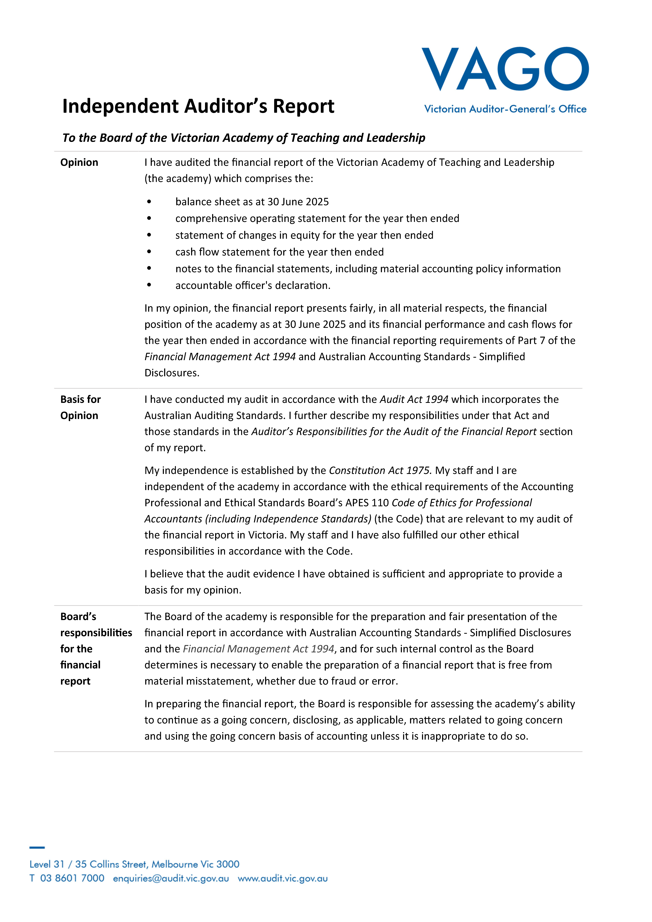
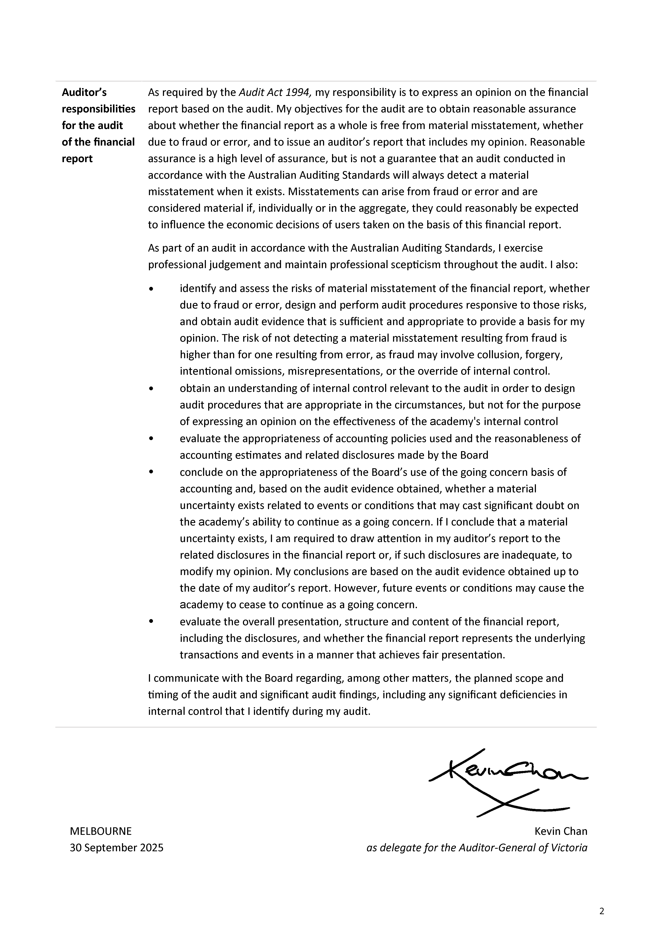

Comprehensive operating statement
for the financial year ended 30 June 2025

 |  | 2025 | 2024
 | Notes | $ | $
Continuing operations
Revenue and income from transactions
Grants | 2.2.1 | 57,394,536 | 57,089,209
Services received free of charge | 2.1 | 1,100,000 | 1,100,000
Total revenue and income from transactions |  | 58,494,536 | 58,189,209
Expenses from transactions
Employee expenses | 3.2.1 | 25,794,407 | 24,078,195
Grant expenses | 3.3 | 5,199,125 | 5,285,166
Contracts and services | 3.4 | 11,932,758 | 15,267,423
Depreciation and amortisation expenses | 4.1.2 | 677,522 | 692,139
Interest expenses | 6.1.1 | 166,833 | 153,157
Other operating expenses | 3.5 | 8,829,359 | 6,221,686
Total expenses from transactions |  | 52,600,004 | 51,697,766
Net result from transactions |  | 5,894,532 | 6,491,443
Total other economic flows – other comprehensive income |  | - | -
Comprehensive result |  | 5,894,532 | 6,491,443

The above comprehensive operating statement should be read in conjunction with the accompanying notes.

Balance sheet as at 30 June 2025

 |  | 2025 | 2024
 | Notes | $ | $
Assets
Financial assets
Receivables | 5.1 | 31,028,053 | 23,586,056
Total financial assets |  | 31,028,053 | 23,586,056
Non-financial assets
Property, plant and equipment | 4.1 | 4,472,487 | 3,794,793
Other non-financial assets | 5.3 | 124,385 | 150,759
Total non-financial assets |  | 4,596,872 | 3,945,552
Total assets |  | 35,624,925 | 27,531,608
Liabilities
Payables | 5.2 | 2,406,694 | 715,484
Borrowings | 6.1 | 4,302,852 | 3,795,277
Other provisions | 5.4 | 309,841 | 309,841
Total liabilities |  | 7,019,387 | 4,820,602
Net assets |  | 28,605,538 | 22,711,006
Equity
Accumulated surplus |  | 22,123,566 | 16,229,034
Contributed capital |  | 6,481,972 | 6,481,972
Net worth |  | 28,605,538 | 22,711,006

The above balance sheet should be read in conjunction with the accompanying notes.

Cash flow statement for the financial year ended 30 June 2025

 |  | 2025 | 2024
 | Notes | $ | $
Cash flows from operating activities
Receipts
Receipts from government |  | 51,052,540 | 52,043,220
Total receipts |  | 51,052,540 | 52,043,220
Payments
Payments of grant expenses |  | (3,523,651) | (5,526,576)
Payments to suppliers and employees |  | (46,514,028) | (45,654,810)
Finance costs paid |  | (166,833) | (153,157)
Total payments |  | (50,204,512) | (51,334,543)
Net cash flows from/(used in) operating activities |  | 848,028 | 708,677
Cash flows from investing activities
Purchases of non‑financial assets |  | (281,642) | (126,524)
Net cash flows from/(used in) investing activities |  | (281,642) | (126,524)
Cash flows from financing activities
Repayment of principal portion of lease liabilities |  | (566,386) | (582,153)
Net cash flows from/(used in) financing activities |  | (566,386) | (582,153)
Net increase/(decrease) in cash and cash equivalents |  | - | -
Cash and cash equivalents at end of the period | 6.3 | - | -
The above cash flow statement should be read in conjunction with the accompanying notes.

Statement of changes in equity
for the financial year ended 30 June 2025

 | Contributed  capital | Accumulated surplus | Total
 | $ | $ | $
Balance at 1 July 2023 | 6,481,972 | 9,737,591 | 16,219,563
Net result for the period | - | 6,491,443 | 6,491,443
Balance at 30 June 2024 | 6,481,972 | 16,229,034 | 22,711,006
Balance at 1 July 2024 | 6,481,972 | 16,229,034 | 22,711,006
Net result for the year | - | 5,894,532 | 5,894,532
Balance at 30 June 2025 | 6,481,972 | 22,123,566 | 28,605,538

The above statement of changes in equity should be read in conjunction with the accompanying notes.

Notes to the financial statements
for the financial year ended 30 June 2025

Note 1 – About this report

The Academy is a not-for-profit entity established under the Education and Training Reform Act 2006 (ETR Act). As an independent public authority, the Academy is a separate legal entity and accountable for resources under its control.
Its principal address is:
Victorian Academy of Teaching and Leadership
41 St Andrews Place
East Melbourne VIC 3002
A description of the nature of Academy operations and its principal activities is included in the Report of operations, which does not form part of these financial statements.

Basis of preparation
These financial statements are Tier 2 general purpose financial statements prepared in accordance with AASB 1060 General Purpose Financial Statements – Simplified Disclosures for For-Profit and Not-for-Profit Tier 2 Entities (AASB 1060) and Financial Reporting Direction 101 Application of Tiers of Australian Accounting Standards (FRD 101).
The Academy is a Tier 2 entity in accordance with FRD 101. These financial statements are the first general purpose financial statements prepared in accordance with Australian Accounting Standards – Simplified Disclosures. The Academy’s prior year financial statements were general purpose financial statements prepared in accordance with Australian Accounting Standards (Tier 1). As the Academy is not a ‘significant entity’ as defined in FRD 101, it was required to change from Tier 1 to Tier 2 reporting effective from 1 July 2024.
These financial statements are in Australian dollars and the historical cost convention is used unless a different measurement basis is specifically disclosed in the note associated with the item measured on a different basis.
The accrual basis of accounting has been applied in preparing these financial statements, whereby assets, liabilities, equity, income and expenses are recognised in the reporting period to which they relate, regardless of when cash is received or paid.
Consistent with the requirements of AASB 1004 Contributions, contributions by owners (that is, contributed capital and its repayment) are treated as equity transactions and, therefore, do not form part of the income and expenses of the Academy.
Capital grants which have been designated as contributions by owners are recognised as contributed capital. Other transfers that are distributions to or contributions by owners have also been designated as contributions by owners.
Judgements, estimates and assumptions are required to be made about financial information being presented. The significant judgements made in the preparation of these financial statements are disclosed in the notes where amounts affected by those judgements are disclosed. Estimates and associated assumptions are based on professional judgements derived from historical experience and various other factors that are believed to be reasonable under the circumstances. Actual results may differ from these estimates.
Revisions to accounting estimates are recognised in the period in which the estimate is revised and also in future periods that are affected by the revision. Judgements and assumptions made by management in applying AAS that have significant effects on the financial statements and estimates are disclosed in the notes under the heading: ‘Significant judgement or estimates’.
These financial statements cover the Academy as an individual reporting entity and include all the controlled activities of the Academy. There is no entity consolidated into the Academy.
All amounts in the financial statements have been rounded to the nearest dollar unless otherwise stated.

Compliance information
These general-purpose financial statements have been prepared in accordance with the Financial Management Act 1994 and applicable Australian Accounting Standards (AASs), which include Interpretations, issued by the Australian Accounting Standards Board (AASB).
Where appropriate, those AASs paragraphs applicable to not-for-profit entities have been applied. Accounting policies selected and applied in these financial statements ensure that the resulting financial information satisfies the concepts of relevance and reliability, thereby ensuring that the substance of the underlying transactions or other events is reported.

Funding dependency
These financial statements have been prepared on a going concern basis.
The Academy has substantial economic dependency on grant revenue received from the Department of Education (DE). 2025-26 funding is confirmed and is sufficient to meet operational requirements. Ongoing financial sustainability is dependent on future government budget decisions. There is a risk that future budget allocations may be reduced due to changes in government priorities, broader economic conditions, or unforeseen policy shifts.

Changes in Accounting policies, including new or revised accounting standards
The Academy has adopted all the new and revised Standards and Interpretations issued by the Australian Accounting Standards Board (AASB) that are relevant to its operations and effective for an accounting period that begins on or after 1 July 2024.
New accounting standards, amendments and interpretations effective for the first time in the current year do not have a material impact on the financial statements of the Academy.

Note 2 – Funding delivery of our services

Introduction
The Academy’s objectives are:
- To improve the outcomes for students through specialised teaching and leadership excellence programs for exceptional teachers and school leaders.
- To increase equity of access to professional learning to lift the quality of teaching across Victoria.
- To raise public awareness of the capability and status of teachers and school leaders in the science and practice of teaching.
- To provide a dedicated pathway for established exceptional teachers to contribute to school system improvement.
- To improve the quality of school leadership.

Structure

2.1 Summary of revenue and income that funds the delivery of our services

2.2 Income from transactions

2.2.1 Grants recognised under AASB 105

2.1 Summary of revenue and income that funds the delivery of our services

 |  | 2025 | 2024
 | Notes | $ | $
Grants | 2.2.1 | 57,394,536 | 57,089,209
Services received free of charge |  | 1,100,000 | 1,100,000
Total revenue and income from transactions |  | 58,494,536 | 58,189,209

Revenue and income that fund delivery of the Academy’s services are accounted for consistently with the requirements of the relevant accounting standards disclosed in the following notes.
The Academy received a rental services free of change from the Department of Education (DE) of $1,100,00 (2024: $1,100,000) to offset the rental expenses charged by DE for three DE owned sites that are used by the Academy for course delivery. The sites are in North Melbourne, Geelong & Ballarat. The expense is recognised within other occupancy costs at note 3.5.

2.2 Income from transactions

2.2.1 Grants recognised under AASB 1058

 | 2025 | 2024
 | $ | $
Grants | 57,394,536 | 57,089,209
Total grants | 57,394,536 | 57,089,209

The Academy has determined that the grant income included in the table above is recognised under AASB 1058 Income for not-for-profit entities on the basis it has been earned under arrangements that are either not enforceable or linked to sufficiently specific performance obligations.
Income from grants without any sufficiently specific performance obligations, or that are not enforceable, is recognised when the Academy has an unconditional right to receive cash which usually coincides with receipt of cash. On initial recognition of the asset, the Academy recognises any related contributions by owners, increases in liabilities, decreases in assets, and revenue (‘related amounts’) in accordance with other Australian Accounting Standards. Related amounts may take the form of:
- contributions by owners, in accordance with AASB 1004 Contributions
- revenue or a contract liability arising from a contract with a customer, in accordance with AASB 15 Revenue from Contracts with Customers
- a lease liability in accordance with AASB 16 Leases
- a financial instrument, in accordance with AASB 9 Financial Instruments
- a provision, in accordance with AASB 137 Provisions, Contingent Liabilities and Contingent Assets.

Note 3 – The cost of delivering services

Introduction
This section provides an account of the expenses incurred by the Academy in delivering services and outputs.
In Section 2, the funds that enable the provision of services were disclosed and in this note the cost associated with provision of services are recorded.

Structure

3.1 Expenses incurred in delivering our services

3.2 Employee expenses

3.2.1 Employee expenses in the comprehensive operating statement

3.2.2 Employee benefits in the balance sheet

3.3 Grant expenses

3.4 Contracts and services

3.5 Other operating expenses

3.1 Expenses incurred in delivering our services

 |  | 2025 | 2024
 | Notes | $ | $
Employee expenses | 3.2.1 | 25,794,407 | 24,078,195
Grant expenses | 3.3 | 5,199,125 | 5,285,166
Contracts and services | 3.4 | 11,932,758 | 15,267,423
Other operating expenses | 3.5 | 8,829,359 | 6,221,686
Total expenses incurred in delivery of services |  | 51,755,649 | 50,852,470

3.2 Employee expenses

3.2.1 Employee expense in the comprehensive operating statement

 | 2025 | 2024
 | $ | $
Defined contribution superannuation expense | 2,410,338 | 2,134,943
Employee on-cost expense | 2,849,415 | 2,628,327
Salaries and wages, annual leave and long service leave | 20,534,654 | 19,314,925
Total employee expenses | 25,794,407 | 24,078,195

Employee expenses included all costs related to the Academy staff who are employees of DE. The Academy reimburses DE for all employee entitlements including wages and salaries, superannuation employer contributions, fringe benefits tax, leave entitlements, termination payments and WorkCover premiums. The costs are classified as employee expenses in the comprehensive operating statement.

3.2.2 Employee benefits in the balance sheet
As per the Education and Training Reform Act 2006 (Vic), for employees in the Academy recognised as employees of DE, their liabilities for long service leave and annual leave are recognised by DE. When a staff member accesses their leave entitlement, it is paid by DE and reduces the accumulated balances of the provision accounts in the DE balance sheet. Provisions for on-costs such as payroll tax, workers compensation and superannuation are recognised separately from the provision for employee benefits.

3.3 Grant expenses

 | 2025 | 2024
 | $ | $
General purpose grants | 5,199,125 | 5,224,000
Payments for specific purposes | - | 61,166
Total grant expenses | 5,199,125 | 5,285,166

Grant expenses are contributions of the Academy’s resources to another party for specific or general purposes where there is no expectation that the amount will be repaid in equal value (either by money, goods or services). Grant expenses include amounts paid to schools for teacher backfill.
Grants can either be operating or capital in nature. Grants can be paid as general-purpose grants, which refer to grants that are not subject to conditions regarding their use. Alternatively, they may be paid as specific purpose grants which are paid for a particular purpose and/or have conditions attached regarding their use.
Grant expenses are recognised in the reporting period in which they are paid or payable. Grants can take the form of money, assets, goods, services or forgiveness of liabilities.

3.4 Contracts and services

 | 2025 | 2024
 | $ | $
Contracts and services | 11,932,758 | 15,267,423
Total contracts and services | 11,932,758 | 15,267,423

The majority of contracts and services includes the engagement of training services for the delivery of the Academy programs which are recognised as an expense in the reporting period in which they were incurred.

3.5 Other operating expenses

 | 2025 | 2024
 | $ | $
Other supplies and services | 2,994,973 | 1,588,825
Information technology expenses | 2,197,053 | 844,171
Other occupancy costs | 3,637,333 | 3,788,690
Total other operating expenses | 8,829,359 | 6,221,686

Other operating expenses generally represent the day-to-day running costs incurred in normal operations.
Other operating expenses includes supplies and services which are recognised as an expense in the reporting period in which they were incurred.
Information technology expenses comprise $1,358,893 of Software as a Service (SaaS) arrangements and other general information technology costs. SaaS arrangements are service contracts providing the Company with the right to access the cloud provider’s application software over the contract period. Costs incurred to configure or customise, and the ongoing fees to obtain access to the cloud provider's application software, are recognised as operating expenses when the services are received.
Included in other occupancy costs is $1,100,000 of rental expenses charged by DE for three DE owned sites that are used by the Academy for course delivery. The sites are in North Melbourne, Geelong & Ballarat. The income for these services provided free of change have been disclosed at note 2.1.

Note 4 – Key assets available to support output delivery

Introduction
The Academy controls buildings, plant and equipment that are utilised in fulfilling its objectives and conducting its activities. This infrastructure represents the resources that have been entrusted to the Academy to be utilised for delivery of those outputs.

Structure

4.1 Total property, plant and equipment

4.1.1 Total right-of-use assets

4.1.2 Depreciation and amortisation

4.1.3 Reconciliation of movements in carrying amounts of property, plant and equipment

4.1 Total property, plant and equipment
 | Gross carrying amount |  | Accumulated depreciation |  | Net carrying amount
 | 2025 | 2024 | 2025 | 2024 | 2025 | 2024
 | $ | $ | $ | $ | $ | $
Office and computer equipment | 561,230 | 279,587 | (239,411) | (209,743) | 321,819 | 69,844
Leasehold improvements | 81,320 | 81,320 | (23,606) | (11,038) | 57,714 | 70,282
Right-of-use assets | 5,969,786 | 4,896,213 | (1,876,832) | (1,241,546) | 4,092,954 | 3,654,667
Net carrying amount | 6,612,336 | 5,257,120 | (2,139,849) | (1,462,327) | 4,472,487 | 3,794,793

Initial recognition and subsequent measurement
Items of property, plant and equipment, are measured initially at cost and subsequently revalued at fair value less accumulated depreciation and impairment. Where an asset is acquired for no or nominal cost, the cost is its fair value at the date of acquisition. Assets transferred as part of a machinery of government change are transferred at their carrying amount.

4.1.1 Total right-of-use assets

 | Gross carrying amount |  | Accumulated depreciation |  | Net carrying amount
 | 2025 | 2024 | 2025 | 2024 | 2025 | 2024
 | $ | $ | $ | $ | $ | $
Leasehold buildings | 5,864,607 | 4,827,540 | (1,851,565) | (1,226,178) | 4,013,042 | 3,601,362
Leased motor vehicles | 105,179 | 68,673 | (25,267) | (15,368) | 79,912 | 53,305
Net carrying amount | 5,969,786 | 4,896,213 | (1,876,832) | (1,241,546) | 4,092,954 | 3,654,667

Right-of-use asset acquired by lessees – Initial measurement
The Academy recognises a right-of-use asset and a lease liability at the lease commencement date.
The right-of-use asset is initially measured at cost which comprises the initial amount of the lease liability adjusted for:
- any lease payments made at or before the commencement date less any lease incentive received
- any initial direct costs incurred
- an estimate of costs to dismantle and remove the underlying asset or to restore the underlying asset or the site on which it is located.

Right-of-use asset – Subsequent measurement
The Academy depreciates the right-of-use assets on a straight-line basis from the lease commencement date to the earlier of the end of the useful life of the right-of-use asset or the end of the lease term. The right-of-use assets are also subject to revaluation.
In addition, the right-of-use asset is periodically reduced by impairment losses, if any, and adjusted for certain remeasurements of the lease liability charge for the period.

4.1.2 Depreciation and amortisation

 | 2025 | 2024
 | $ | $
Office and computer equipment | 29,668 | 10,928
Leasehold buildings | 625,387 | 669,988
Leasehold Improvements | 12,568 | 3,083
Leased motor vehicles | 9,899 | 8,140
Total depreciation and amortisation | 677,522 | 692,139

All buildings, plant and equipment that have finite useful lives, are depreciated. The exceptions to this rule include items under assets held for sale, cultural assets and land.
Depreciation is generally calculated on a straight-line basis, at rates that allocate the asset’s value, less any estimated residual value, over its estimated useful life.
The following estimated useful lives are used in the calculation of depreciation:

Asset | Useful life years
Leasehold buildings | 10 years
Leasehold improvements | 3-10 years
Office and computer equipment | 3-10 years
Leased motor vehicles | 3-10 years

The estimated useful lives, residual values and depreciation method are reviewed at the end of each annual reporting period, and adjustments made where appropriate.

Right-of-use assets are generally depreciated over the shorter of the asset’s useful life and the lease term. Where the Academy obtains ownership of the underlying leased asset or if the cost of the right-of-use asset reflects that the entity will exercise a purchase option, the entity depreciates the right-of-use asset over its useful life.
Leasehold improvements are depreciated over the shorter of the lease term and their useful lives.

4.1.3 Reconciliation of movements in carrying amounts of property, plant and equipment

2025 | Office  and computer equipment | Leasehold improvements | Leasehold buildings | Leased  motor vehicles | Total
 | $ | $ | $ | $ | $
Balance at 1 July 2024 | 69,844 | 70,282 | 3,601,362 | 53,305 | 3,794,793
Remeasurement – cost ^{(i)} | - | - | (150,257) | - | (150,257)
Additions | 281,643 | - | 1,187,324 | 36,506 | 1,505,473
Disposals | - | - | - | - | -
Depreciation | (29,668) | (12,568) | (625,387) | (9,899) | (677,522)
Closing balance – 30 June 2025 | 321,819 | 57,714 | 4,013,042 | 79,912 | 4,472,487

- During the financial year, the Academy remeasured four of its leased properties to reflect a change in CPI linked to the contractual payments of the leases which resulted in a change in future lease payments.

Note 5 – Other assets and liabilities

Introduction
This section sets out those assets and liabilities that arose from the Academy’s controlled operations.

Structure

5.1 Receivables

5.2 Payables

5.3 Other non-financial assets

5.4 Other provisions

5.1 Receivables

 | 2025 | 2024
 | $ | $
Contractual receivables
Amounts owing from Government | 31,028,053 | 23,586,056
Total receivables | 31,028,053 | 23,586,056
Represented by:
Current receivables | 31,028,053 | 23,586,056

Receivables includes amounts owing from government through accounts receivable.
Receivables consist of contractual receivables which are classified as financial instruments and categorised as ‘financial assets at amortised cost’. They are initially recognised at fair value plus any directly attributable transaction costs. The Academy holds the contractual receivables with the objective to collect the contractual cash flows and therefore subsequently measured at amortised cost using the effective interest method, less any impairment.
The Academy assesses at each reporting date, whether there is an indication that a contractual receivable may be impaired. The Academy did not recognise expected credit losses at 30 June 2025 (2024: Nil).

5.2 Payables

 | 2025 | 2024
 | $ | $
Contractual payables
Creditors and accruals | 491,732 | 594,665
Amounts payable to Government | 1,816,440 | 120,819
Statutory payables
Salaries accruals | 80,987 | -
FBT and other tax payables | 17,535 | -
Total payables | 2,406,694 | 715,484
Represented by:
Current payables | 2,406,694 | 715,484

Payables consist of:
- Contractual payables: Classified as financial instruments and measured at amortised cost. Accounts payable represent liabilities for goods and services provided to the Academy prior to the end of the financial year that are unpaid.
- Statutory payables: Recognised and measured similarly to contractual payables, but not classified as financial instruments and not included in the category of financial liabilities at amortised cost, because they do not arise from contracts.
Payables for creditors and accruals have an average credit period less than 30 days. The terms and conditions of amounts payable to the government and agencies vary according to the particular agreements and as they are not legislative payables, they are classified as financial instruments.

5.3 Other non-financial assets

 | 2025 | 2024
 | $ | $
Current other assets
Prepayments | 124,385 | 150,759
Total current other assets | 124,385 | 150,759

Other non-financial assets include prepayments, which represent payments in advance of receipt of goods or services or the payments made for services covering a term extending beyond that financial accounting period.

5.4 Other provisions

 | 2025 | 2024
 | $ | $
Non-current provisions
Make-good provisions | 309,841 | 309,841
Total non-current provisions | 309,841 | 309,841

Other provisions are recognised when the Academy has a present obligation, the future sacrifice of economic benefits is probable, and the amount of the provision can be measured reliably. The amount recognised as a provision is the best estimate of the consideration required to settle the present obligation at reporting date, taking into account the risks and uncertainties surrounding the obligation.
Where a provision is measured using the cash flows estimated to settle the present obligation, its carrying amount is the present value of those cash flows, using a discount rate that reflects the time value of money and risks specific to the provision. During the current year the discounting of the make-good provision is immaterial and as a result has been rounded to nil.

Reconciliation of movements in other provisions

Make-good
provision
 | $
Opening balance | 309,841
Make-good provision settled during the year | -
Closing balance – 30 June 2025 | 309,841

The make-good provision is recognised in accordance with the lease agreement over the facilities. The Academy may be required to remove any leasehold improvements from the leased facilities and restore the premises to their original condition at the end of the lease term.

Note 6 – How we financed our operations

Introduction
This section provides information on the sources of finance utilised by the Academy during its operations, along with interest expense (the cost of leases) and other information related to financing activities of the Academy.
This section includes disclosures of balances that are financial instruments.

Structure

6.1 Borrowings

6.1.1 Interest expense

6.2 Leases

6.2.1 Right-of-use assets

6.2.2 Recognition and measurement of leases as a lessee

6.3 Cashflow information and balances

6.4 Commitments for expenditure

6.1 Borrowings

 | 2025 | 2024
 | $ | $
Current borrowings
Lease liabilities ^{(i)} | 435,069 | 520,088
Total current borrowings | 435,069 | 520,088
Non-current borrowings
Lease liabilities ^{(i)} | 3,867,783 | 3,275,189
Total non-current borrowings | 3,867,783 | 3,275,189
Total borrowings | 4,302,852 | 3,795,277

- Secured by the assets leased. Leases liabilities are effectively secured as the rights to the leased assets revert to the lessor in the event of default.
‘Borrowings’ refer to interest bearing liabilities arising from leases.
Borrowings are classified as financial instruments. Interest bearing liabilities, including lease liabilities recognised in accordance with AASB 16, are classified at amortised cost and recognised at the fair value of the consideration received less directly attributable transaction costs and subsequently measured at amortised cost using the effective interest method.

Terms and conditions of borrowings

 |  |  |  |  |  |  | Maturity dates
 | Carrying amount | Nominal amount | Less than  1 month | 1-3  months | 3 months  – 1 year | 1-5  years | 5+  years
2025
Lease liabilities | 4,302,852 | 5,108,080 | 63,054 | 101,051 | 460,780 | 2,553,333 | 1,929,862
Total | 4,302,852 | 5,108,080 | 63,054 | 101,051 | 460,780 | 2,553,333 | 1,929,862
2024
Lease liabilities | 3,795,277 | 4,422,146 | 58,762 | 176,286 | 432,170 | 1,965,789 | 1,789,139
Total | 3,795,277 | 4,422,146 | 58,762 | 176,286 | 432,170 | 1,965,789 | 1,789,139

The weighted average incremental borrowing rate of the Academy’s lease liabilities is 4.2% (2024: 3.7%).

6.1.1 Interest expense

 | 2025 | 2024
 | $ | $
Interest on lease liabilities | 166,833 | 153,157
Total interest expense | 166,833 | 153,157

Interest expense includes costs incurred in connection with the interest component of lease repayments. Interest expense is recognised in the period in which it is incurred.

6.2 Leases
Information about leases for which the Academy is a lessee is presented below.

The Academy’s leasing activities
The Academy leases various properties and motor vehicles. The lease contracts are typically made for fixed periods of 1-10 years with an option to renew the lease after that date. Lease payments for properties are renegotiated every five years or on commencement of a further term to reflect market rentals.

6.2.1 Right-of-use assets
Right-of-use assets are presented in note 4.1.1.

6.2.2 Recognition and measurement of leases as a lessee
For any new contracts entered into, the Academy considers whether a contract is, or contains a lease. A lease is defined as ‘a contract, or part of a contract, that conveys the right to use an asset (the underlying asset) for a period of time in exchange for consideration’. To apply this definition the Academy assesses whether the contract meets three key evaluations:
- whether the contract contains an identified asset, which is either explicitly identified in the contract or implicitly specified by being identified at the time the asset is made available to the Academy and for which the supplier does not have substantive substitution rights.
- whether the Academy has the right to obtain substantially all of the economic benefits from use of the identified asset throughout the period of use, considering its rights within the defined scope of the contract and the Academy has the right to direct the use of the identified asset throughout the period of use
- whether the Academy has the right to take decisions in respect of ‘how and for what purpose’ the asset is used throughout the period of use.

Lease Liability – initial measurement
The lease liability is initially measured at the present value of the lease payments unpaid at the commencement date, discounted using the interest rate implicit in the lease if that rate is readily determinable or the Academy’s incremental borrowing rate.
Lease payments included in the measurement of the lease liability comprise the following:
- fixed payments (including in-substance fixed payments) less any lease incentive receivable
- variable payments based on an index or rate, initially measured using the index or rate as at the commencement date
- amounts expected to be payable under a residual value guarantee
- payments arising from purchase and termination options reasonably certain to be exercised.

Lease Liability – subsequent measurement
Subsequent to initial measurement, the liability will be reduced for payments made and increased for interest. It is remeasured to reflect any reassessment or modification, or if there are changes in-substance fixed payments.

Presentation of right-of-use assets and lease liabilities
The Academy presents right-of-use assets as ‘property plant equipment’ (refer to note 4.1) unless they meet the definition of investment property, in which case they are disclosed as ‘investment property’ in the balance sheet. Lease liabilities are presented as ‘borrowings’ in the balance sheet (refer to note 6.1).

Future lease payments

Minimum future lease payments ^{(i)} | 2025 | 2024
 | $ | $
Not longer than 1 year | 624,885 | 667,218
Longer than 1 year but not longer than 5 years | 2,553,333 | 1,965,789
Longer than 5 years | 1,929,862 | 1,789,139
Minimum future lease payments | 5,108,080 | 4,422,146
Less future finance charges | (805,228) | (626,869)
Present value of minimum lease payments | 4,302,852 | 3,795,277

- Minimum future lease payments include the aggregate of all base payments and any guaranteed residual.

6.3 Cash flow information and balances
Cash and deposits comprise cash on hand and cash at bank. The Academy does not have its own bank account and continues to use the DE’s bank account for general expense and transactions.

6.4 Commitments for expenditure
Commitments for future expenditure include operating commitments arising from contracts. These commitments are recorded below at their nominal value and inclusive of GST. Where it is considered appropriate and provides additional relevant information to users, the net present values of significant individual projects are stated. These future expenditures cease to be disclosed as commitments once the related liabilities are recognised in the balance sheet.

Nominal amount | Less than 1 year | 1 year – 5 years | Total
 | $ | $ | $
2025
Operating commitments payable | 2,148,828 | 589,716 | 2,738,544
Total commitments | 2,148,828 | 589,716 | 2,738,544
2024
Operating commitments payable | 2,005,734 | 776,826 | 2,782,560
Total commitments | 2,005,734 | 776,826 | 2,782,560

Note 7 – Risks, contingencies, and valuation judgements

Introduction
It is often necessary for the Academy to make judgements and estimates associated with recognition and measurement of items in the financial statements.
This section sets out financial instrument specific information, as well as those items that are contingent in nature or require a higher level of judgement to be applied, which for the Academy related mainly to fair value determination.

Structure

7.1 Financial instruments specific disclosures

7.1.1 Financial instruments – net gain/(loss) on financial instruments by category

7.2 Contingent liabilities

7.3 Fair value determination

7.3.1 Fair value determination: Non-financial physical assets

7.1 Financial instruments specific disclosures
Financial instruments arise out of contractual agreements that give rise to a financial asset of one entity and a financial liability or equity instrument of another entity. Due to the nature of the Academy’s activities, certain financial assets and financial liabilities arise under statute rather than a contract (for example taxes, fines and penalties). Such assets and liabilities do not meet the definition of financial instruments in AASB 132 Financial Instruments: Presentation.

Categories of financial assets

Financial assets at amortised cost
Financial assets are measured at amortised cost if both of the following criteria are met and the assets are not designated as fair value through net result:
- the assets are held by the Academy to collect the contractual cash flows
- the assets’ contractual terms give rise to cash flows that are solely payments of principal and interests.
These assets are initially recognised at fair value plus any directly attributable transaction costs and subsequently measured at amortised cost using the effective interest method less any impairment.
The Academy recognises contractual receivables in this category.

Categories of financial liabilities

Financial liabilities at amortised cost
Financial liabilities at amortised cost are initially recognised on the date they are originated. They are initially measured at fair value plus any directly attributable transaction costs. Subsequent to initial recognition, these financial instruments are measured at amortised cost with any difference between the initial recognised amount and the redemption value being recognised in profit and loss over the period of the interest-bearing liability, using the effective interest rate method.
The Academy recognises the following liabilities in this category:
- payables (excluding statutory payables)
- borrowings (including lease liabilities)

7.1.1 Financial instruments – net gain/(loss) on financial instruments by category

 | Carrying amount | Net gain / loss | Impairment loss | Total interest  income/ (expense)
 | $ | $ | $ | $
2025
Financial assets at amortised cost
Amounts owing from government | 31,028,053 | - | - | -
Total financial assets at amortised cost | 31,028,053 | - | - | -
Financial liabilities at amortised cost
Contractual payables | 2,308,172 | - | - | -
Borrowings | 4,302,852 | - | - | (166,833)
Total financial liabilities at amortised cost | 6,611,024 | - | - | (166,833)
2024
Financial assets at amortised cost
Amounts owing from government | 23,586,056 | - | - | -
Total financial assets at amortised cost | 23,586,056 | - | - | -
Financial liabilities at amortised cost
Contractual payables | 715,484 | - | - | -
Borrowings | 3,795,277 | - | - | (153,157)
Total financial liabilities at amortised cost | 4,510,761 | - | - | (153,157)

7.2 Contingent liabilities
Contingent liabilities are:
- possible obligations that arise from past events, whose existence will be confirmed only by the occurrence or non-occurrence of one or more uncertain future events not wholly within the control of the entity.
- present obligations that arise from past events but are not recognised because it is not probable that an outflow of resources embodying economic benefits will be required to settle the obligations the amount of the obligations cannot be measured with sufficient reliability. These are classified as either quantifiable or non-quantifiable.
Contingent liabilities are also classified as either quantifiable or non-quantifiable.
As at 30 June 2025 the Academy had no contingent assets and no contingent liabilities.

7.3 Fair value determination
This section sets out information on how the Academy determined fair value for financial reporting purposes. Fair value is the price that would be received to sell an asset or paid to transfer a liability in an orderly transaction between market participants at the measurement date.

Fair value hierarchy
In determining fair values, a number of inputs are used. To increase consistency and comparability in the financial statements, these inputs are categorised into three levels, also known as the fair value hierarchy. The levels are as follows:
- Level 1 – quoted (unadjusted) market prices in active markets for identical assets or liabilities
- Level 2 – valuation techniques for which the lowest level input that is significant to the fair value measurement is directly or indirectly observable
- Level 3 – valuation techniques for which the lowest level input that is significant to the fair value measurement is unobservable.
The Academy determines whether transfers have occurred between levels in the hierarchy by reassessing categorisation (based on the lowest level input that is significant to the fair value measurement as a whole) at the end of each reporting period.
The Valuer General Victoria (VGV) is the Academy’s independent valuation agency. In conjunction with VGV, the Academy monitors changes in the fair value of each asset and liability through relevant data sources to determine whether revaluation is required.

How this section is structured
For those assets and liabilities for which fair values are determined, the following disclosures are provided:
- valuation techniques
- details of significant assumptions used in the fair value determination.

7.3.1 Fair value determination: Non-financial physical assets
There have been no transfers between levels during the period.
Plant and equipment is held at fair value. When plant and equipment is specialised in use, such that it is rarely sold other than as part of a going concern, fair value is determined using the current replacement cost method.
Building and vehicle right-of-use assets are held at fair value.
For all assets measured at fair value, the current use is considered the highest and best use.

Note 8 – Other disclosures

Introduction
This section includes additional material disclosures required by accounting standards or otherwise, for the understanding of this financial report.

Structure

8.1 Ex-gratia expenses

8.2 Responsible persons

8.3 Remuneration of executives

8.4 Related parties

8.5 Remuneration of auditors

8.6 Subsequent events

8.1 Ex-gratia expenses
Ex gratia expenses are the voluntary payments of money or other non-monetary benefit (e.g. a write off) that are not made either to acquire goods, services or other benefits for the entity or to meet a legal liability, or to settle or resolve a possible legal liability of or claim against the entity.
As at 30 June 2025, the Academy had not made any ex-gratia payments (2024: nil).

8.2 Responsible persons
In accordance with the Ministerial Directions issued by the Minister of Finance under the Financial Management Act 1994, the following disclosures are made regarding responsible persons for the reporting period.
The persons who held the positions of Ministers and Accountable Officers in the Academy are as follows:

Position | Name | Occupancy period
Minister for Education | The Hon. Ben Carroll MP | 2 October 2023 – 30 June 2025
Secretary of the Department of Education | Ms Jenny Atta | 1 July 2024 – 28 February 2025
A/Secretary of the Department of Education | Tony Bates | 1 March 2025 – 30 June 2025
Chief Executive Officer | Dr Marcia Devlin AM | 1 July 2024 – 30 June 2025

Remuneration received or receivable by the Accountable Officer in connection with the management of the Academy during the reporting period was in the range: $400,000 – $419,999 (2024: $380,000 – $389,999).

8.3 Remuneration of executives
The number of senior executive service members, other than Ministers and accountable officers, and their total remuneration during the reporting period are shown in the below table. Total annualised employee equivalents provides a measure of full time equivalent executive officers over the reporting period.
Remuneration comprises employee benefits (as defined in AASB 119 Employee Benefits) in all forms of consideration paid, payable or provided by the entity, or on behalf of the entity, in exchange for services rendered. Accordingly, remuneration is determined on an accrual basis.

Remuneration of executive officers | 2025 | 2024
 | $ | $
Total remuneration ^{(i)} | 951,347 | 904,236
Total number of executives | 3 | 3
Total annualised employee equivalents ^{(ii)} | 3.0 | 3.0

- The total number of senior executive service members includes persons who meet the definition of Key Management Personnel (KMP) of the entity under AASB 124 Related Party Disclosures and are also reported within the related parties note disclosure (Note 8.4).
- Annualised employee equivalent is based on paid working hours of 38 ordinary hours per week over the 52 weeks for the reporting period.

8.4 Related parties
The Academy is a wholly owned and controlled entity of the State of Victoria. Related parties of the Academy include:
- all key management personnel and their close family members;
- all Cabinet Ministers and their close family members; and
- all departments and public sector entities that are controlled and consolidated into the whole-of-state consolidated financial statements.

Significant transactions with government-related entities
For the financial year ended 30 June 2025 the Academy received income from grants of $58,494,536 from DE (2024: $58,189,209). The Academy made payments of $1,551,384 for occupancy costs to DE for 41 St Andrew Place East Melbourne (2024: $1,493,942) and $1,100,000 to DE for three DE owned sites of North Melbourne, Geelong & Ballarat that are used by the Academy for course delivery (2024: $1,100,000).

Key management personnel
Key management personnel (KMP) of the Academy during the financial year include the Portfolio Minister, the Secretary of the Department of Education, Board Members, the Accountable Officer and senior executive managers. These include the following:

Name | Position title | Occupancy period
Dr Marcia Devlin AM | Chief Executive Officer | 1/7/2024 – 30/6/2025
Peter Saffin | Chief Operating Officer | 1/7/2024 – 30/6/2025
Dr Toni Meath | Board Chair | 1/7/2024 – 30/6/2025
Judith Downes | Board member and Audit and Risk Committee Chair | 1/7/2024 – 31/3/2025
Lucy Amon | Board member | 26/11/2024 – 30/6/2025
Prof Viv Ellis | Board member | 1/7/2024 – 31/3/2025
Dr David Howes | Board member | 1/7/2024 – 09/1/2025
Martin Keogh | Board member | 1/7/2024 – 30/6/2025
Christine Lucas | Board member | 1/4/2025 – 30/6/2025
Kieren Noonan | Board member | 1/7/2024 – 15/10/2024
Nicole Pollard | Board member | 1/4/2025 – 30/6/2025
Chris Thompson | Board member | 10/1/2025 – 30/6/2025
Chris Walsh | Board member | 1/4/2025 – 30/6/2025

The compensation detailed below excludes the salary and benefit the Portfolio Minister receives. The Minister’s remuneration and allowance are set by the Parliamentary Salaries and Superannuation Act 1968 and are reported in the financial report of the State’s Annual Financial Report.

Compensation of KMP | 2025 | 2024
 | $ | $
Total remuneration ^{(i)} | 788,056 | 759,712

- Note that KMPs are also reported in the disclosure of remuneration of executive officers (Note 8.3)

Transactions with KMPs and other related parties
Given the breadth and depth of State government activities, related parties transact with the Victorian public sector in a manner consistent with other members of the public. Further employment of processes within the Victorian public sector occur on terms and conditions consistent with the Public Administration Act 2004 and Codes of Conduct and Standards issued by the Victorian Public Sector Commission. Procurement processes occur on terms and conditions consistent with the Victorian Government Procurement Board requirements.
Outside of normal citizen type transactions with the Academy, there were no related party transactions that involved KMPs and their close family members. No provision has been required, nor any expense recognised, for impairment of receivables from related parties.

8.5 Remuneration of auditors

 | 2025 | 2024
 | $ | $
Victorian Auditor-General’s Office
Audit or review of the financial statements | 50,600 | 44,720
Total remuneration of auditors | 50,600 | 44,720

8.6 Subsequent events
There are no known subsequent events that will have a material impact on the financial statements.
The policy in connection with recognising subsequent events that are for events that occur between the end of the reporting period and the date when the financial statements are authorised for issue is as follows:
- adjustments are made to amounts recognised in the financial statements where those events provide information about conditions that existed at the reporting date; and/or
- disclosure is made where the events relate to conditions that arose after the end of the reporting period that are considered to be of material interest.

Appendices

Appendix 1: Standing Directions and Financial Reporting Directions

Legislation Requirement | Page
Report of operations
Charter and purpose
FRD 22 Manner of establishment and the relevant Ministers | 6, 26
FRD 22 Purpose, functions, powers and duties | 6
FRD 22 Key initiatives and projects | 12-23
FRD 22 Nature and range of services provided | 12-23
Management and structure
FRD 22 Organisational structure | 36
Financial and other information
FRD 8 Performance against output performance measures | 24
FRD 10 Disclosure index | 86
FRD 12 Disclosure of major contracts | 46
FRD 15 Executive disclosures | 82-84
FRD 22 Employment and conduct principles | 38
FRD 22 Occupational health and safety policy | 37
FRD 22 Subsequent events | 85
FRD 22 Application and operation of Freedom of Information Act 1982 | 46
FRD 2 Compliance with building and maintenance provisions of Building Act 1993 | 47
FRD 22 Statement on National Competition Policy | 47
FRD 22 Application and operation of the Public Interest Disclosures Act 2012 | 47
FRD 22 Application and operation of the Carers Recognition Act 2012 | 48
FRD 22 Details of consultancies over $10,000 | 45
FRD 22 Details of consultancies under $10,000 | 45
FRD 22 Disclosure of government advertising expenditure | 44
FRD 22 Disclosure of ICT expenditure | 46
FRD 22 Statement of availability of other information | 50
FRD 22 Asset Management Accountability Framework (AMAF) maturity assessment | n/a
FRD 22 Disclosure of emergency procurement | n/a
FRD 24 Environmental reporting | 48-49
FRD 25 Local jobs first | 44
FRD 29 Workforce Data disclosures | 40-41
SD 5.2 Specific requirements under Standing Direction 5.2 | 54
Compliance attestation and declaration
SD 5.4.1 Attestation for compliance with Ministerial Standing Direction | 51
SD 5.2.3 Declaration in report of operations | 4
Financial Statements
Declaration
SD 5.2.2 Declaration in financial statements | 54
Other requirements under Standing Directions 5.2
SD 5.2.1(a) Compliance with Australian accounting standards and other authoritative pronouncements | 62
Other disclosures as required by FRDs in notes to the financial statements
FRD 11 Disclosure of Ex gratia Expenses | 82
FRD 21 Disclosures of Responsible Persons, Executive Officers and other Personnel  (Contractors with Significant Management Responsibilities) in the Financial Report | 82
FRD 103 Non-Financial Physical Assets | 80
FRD 110 Cash Flow Statements | 78
FRD 112 Defined Benefit Superannuation Obligations | 66
FRD 114 Financial Instruments – general government entities and public non-financial corporations | 79
Legislation
Freedom of Information Act 1982 | 46
Building Act 1993 | 47
Public Interest Disclosures Act 2012 | 47
Carers Recognition Act 2012 | 48
Disability Act 2006 | 48
Local Jobs Act 2003 | 44
Financial Management Act 1994 | 51

Appendix 2: Board meeting attendance

There were 6 Board meetings during the reporting period.
 = Attended = Apology  = Leave of Absence approved by the Chair or Minister

Board member | 16 Jul 24 | 20 Sep 24 | 21 Oct 24 | 16 Dec 24 | 3 Mar 25 | 12 May 25 | Overall
Dr Toni Meath (Chair) |  |  |  |  |  |  | 4/6
Martin Keogh |  |  |  |  |  |  | 6/6
Christine Lucas |  |  |  |  |  |  | 0/1
Chris Thompson |  |  |  |  |  |  | 2/2
Lucy Amon |  |  |  |  |  |  | 3/3
Nicole Pollard |  |  |  |  |  |  | 1/1
Chris Walsh |  |  |  |  |  |  | 1/1
Dr David Howes (until Jan 25) |  |  |  |  |  |  | 4/4
Judith Downes (until 31 Mar 25) |  |  |  |  |  |  | 4/5
Professor Viv Ellis (until 31 Mar 25) |  |  |  |  |  |  | 2/5
Chris Wardlaw  (acting Chair Nov 24 – Jan 25) |  |  |  |  |  |  | 1/1
Kieren Noonan (until 15 Oct 24) |  |  |  |  |  |  | 2/2

There were 5 Audit and Risk Committee meetings during the reporting period.
= Attended = Apology = Leave of Absence approved by the Chair

ARC member | 30 Jul 24 | 16 Sep 24 | 18 Nov 24 | 31 Mar 25 | 24 Jun 25 | Overall
Martin Keogh (from Nov 24) |  |  |  |  |  | 3/3
Christine Lucas (from 13 May 25) |  |  |  |  |  | 1/1
Chris Walsh (from 13 May 25) |  |  |  |  |  | 1/1
Kathryn Brown (Chair) (from 27 May 25) |  |  |  |  |  | 1/1
Judith Downes (Chair) (until 31 Mar 25) |  |  |  |  |  | 4/4
Kieren Noonan (until 15 Oct 24) |  |  |  |  |  | 2/2
Professor Viv Ellis (until 31 Mar 25) |  |  |  |  |  | 3/4
Ella McPherson (until Mar 25) |  |  |  |  |  | 3/3

Appendix 3: Acronyms and abbreviations
AAS | Australian Accounting Standards
AASB | Australian Accounting Standards Board
ALEF | Academy Leadership Excellence Framework
BAU | business-as-usual
BP3 | Victorian Budget 2025/26 Budget Paper No. 3: Service Delivery
CEO | Chief Executive Officer
COO | Chief Operating Officer
code of conduct | Code of Conduct for Victorian Public Sector Employees
DE | Department of Education (Victoria)
EEC | Evidence and Evaluation Centre
EMS | Environmental Management System
ETR Act | Education and Training Reform Act 2006 (Vic)
FM Act | Financial Management Act 1994 (Vic)
FOI | freedom of information
FOI Act | Freedom of Information Act 1982 (Vic)
FRD | Financial Reporting Direction (under the FM Act)
FTE | full-time equivalent
GST | Goods and Services Tax
ICT | information and communication technology
KMP | key management personnel
Marrung | Marrung Aboriginal Education Plan 2016–2026
OHS | occupational health and safety
PID | public interest disclosure
PID Act | Public Interest Disclosures Act 2012 (Vic)
SEIL | Senior Education Improvement Leader
SSP | Shared Service Provider
the Academy | Victorian Academy of Teaching and Leadership
TELC | Teaching Excellence Learning Community
TEP | Teaching Excellence Program
VAPA | Victorian Aspiring Principal Assessment
VCAA | Victorian Curriculum and Assessment Authority
VSBA | Victorian School Building Authority

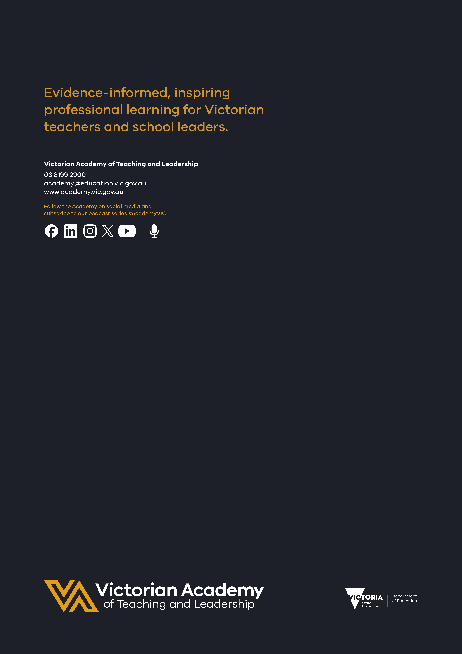

Department Performance Statement targets are set and reported by financial year; however, the Academy reports outcomes against these targets by calendar year. For example, for the 2024–25 financial year the Academy will report outcomes from 2024 calendar year data, and for the 2025–26 financial year the Academy will report outcomes from 2025 calendar year data.

